

SIM BING RUI (U1920018H)

**Robot X 2022: Development of an Object Delivery System of USV**

**SCHOOL OF MECHANICAL AND AEROSPACE ENGINEERING**

**NANYANG TECHNOLOGICAL UNIVERSITY**

**Year (2021/2022)**

**Robot X 2022: Development of an Object Delivery System of USV**

SUBMITTED

BY

**SIM BING RUI**

SCHOOL OF MECHANICAL AND AEROSPACE ENGINEERING

NANYANG TECHNOLOGICAL UNIVERSITY

A final year project report

presented to

Nanyang Technological University

In partial fulfilment of the requirements for the

Degree of Bachelor of Engineering (Mechanical Engineering) Nanyang Technological University

Year (2021/2022)

# **Abstract**

Maritime RobotX Challenge consists of various autonomous challenges with an emphasis on science and cooperative autonomy. Singapore is a country that flourishes based on its maritime port, autonomous systems that improve maritime capabilities are of great interest. For the project, a robotic arm and UAV platform are developed to accomplish an autonomous delivery system of an object. The system would include perception, mobility, and manipulation functionalities to complete the task of object delivery. Having an object delivery system, the project capabilities can be further extended into commercial systems. With the development of industrial 4.0, the autonomous systems could be used in the warehouse to deliver inventories or aid in the automation of food delivery or parcels services. Therefore, there is great potential in the development of autonomous delivery systems.

# **Acknowledgement**

The student would like to extend his gratitude to the following personnel/body:

Firstly, the student would like to thank the School of MAE for providing the opportunity to challenge themselves by having a Final Year Project. Where the students have the opportunity to learn, experience and showcase their capabilities in technical capabilities, as well as project management skills, learnt throughout their education.

Next, the student would like to express his gratitude to his project supervisor, Associate Professor Xie Ming for providing technical guidance and directions as well as the liberty of expanding the project based on the student’s interests and Mr Long who aided in the timely printing of 3D models used for the project.

The student would also like to thank the developers of software and hardware which aided in the completion of the project. This includes the Ardupilot, ESPUI, MAVLINK, Jetson Nano, ESP32, YOLO, ROS and PyBullet.

Lastly, he would like to thank his fellow friends, family and coursemates who provided support and suggestions for the improvements to the project.

# **Acronyms**

|  |  |  |
| --- | --- | --- |
| BLDC | Brushless Direct Current | |
| CCD | Cyclic Coordinate Descent | |
| CNN | Convolutional Neural Network | |
| COCO | Common Objects in Context | |
| DH | Denavit-Hartenberg | |
| DOF | Degrees of Freedom | |
| EKF | Extended Kalman filter | |
| ESC | Electronic Speed controller | |
| FABRIK | Forward and Backward Inverse Kinematics | |
| FEA | Finite Element Analysis | |
| FK | Forward Kinematics | |
| FPS | Frames per Second | |
| GCS | Ground Control System | |
| GCU | Ground Control Unit | |
| GPS | Global Positioning System | |
| GUI | Graphical User Interface | |
| IK | Inverse Kinematics | |
| IMU | Inertia Measurement Unit | |
| LIDAR | Light Detection and Ranging | |
| MCU | Microcontroller unit | |
| PCM | Pulse-code modulation | |
| PID | Proportional Integral Derivative | |
| PLA | Polylactic Acid | |
| PPM | Pulse-position modulation | |
| PWM | Pulse-width modulation | |
| RC | Radio Control | |
| RCNN | Region-based Convolutional Neural Network | |
| ROI | Return on Investment | |
| ROS | Robot Operating System | |
| RTL | Return to Land | |
| SITL | Software in the loop | |
| SLAM | Simultaneous Localisation and Mapping | |
| SSD | Single Shot MultiBox Detector | |
| SSH | Secure Shell | |
| TCP | Transmission Control Protocol | |
| UAV | Unmanned Aerial Vehicle | |
| URDF | Unified Robotics Description Format | |
| USV | Unmanned Surface Vehicle | |
| VSLAM | Visual Simultaneous Localisation and Mapping | |
| XML | Extensible Markup Language | |
| YOLO | You Only Look Once | |
| **Figures** | |

Figure 1‑1: USV Heartbeat 1

Figure 1‑2: Exit and Entrance 1

Figure 1‑3: Follow the Path 1

Figure 1‑4: React and Report 1

Figure 1‑5: Scan the Code 1

Figure 1‑6: Detect and Dock 1

Figure 1‑7: Find and Fling 1

Figure 1‑8: UAV Replenishment 1

Figure 1‑9: UAV Search and Report 1

Figure 1‑10: Mission Detailed Layout 2

Figure 1‑11: Find and Fling Task Elements 2

Figure 1‑12: Propelling of Projectile [1] 3

Figure 1‑13: TossingBot [2] 3

Figure 1‑14: Industrial Robots [3] 3

Figure 1‑15: Magnus Effect [5] 4

Figure 1‑16: Open vs Closed Loop [6] 4

Figure 1‑17: Workspace of Meca500 Robot [7] 4

Figure 1‑18: Bumblebee System [8] 4

Figure 1‑19: NaviGatorUF System [10] 4

Figure 1‑20: UON USV [9],[11] 4

Figure 1‑21: Square Cube Law [12] 5

Figure 1‑22: Sizing of Robotic Arm [13] 5

Figure 1‑23: UAV DOFs [14] 5

Figure 3.1‑1: ABB Robotic Arm [15] 6

Figure 3.1‑2: FANUC Robotic Arm [16] 6

Figure 3.1‑3: KUKA Robotic Arm [17] 6

Figure 3.2‑1: IRB 7600 Coordinate System [19] 8

Figure 3.2‑2: Visualisation of FABRIK [21] 10

Figure 3.2‑3: XML URDF sample 11

Figure 3.2‑4: Simulation of URDF Model 12

Figure 3.3‑1: PID Controller [22] 12

Figure 3.3‑2: Categories of UAVs [23] 12

Figure 3.3‑3: Ardupilot Vehicle Firmware 13

Figure 3.4‑1: 5x5 Gaussian Kernel [24] 14

Figure 3.4‑2: 3D Plot of Gaussian Kernel [25] 14

Figure 3.4‑3: Orignial Image 14

Figure 3.4‑4: Blurred Image after Kernel 14

Figure 3.4‑5: Image after Sobel Kernel 14

Figure 3.4‑6: Non-max Suppression 14

Figure 3.4‑7: Double Thresholding 14

Figure 3.4‑8: RCNN Architecture 15

Figure 3.4‑9: Fast RCNN Architecture 16

Figure 3.4‑10: Performance Comparison 16

Figure 3.4‑11: YOLO Detection Model 17

Figure 3.4‑12: SSD Detection Model 17

Figure 3.4‑13: SSD vs YOLO Architecture 18

Figure 5‑1: Robotic Arm Functional Diagram 19

Figure 5‑2: UAV Functional Diagram 19

Figure 5‑3: Robotic Arm full process diagram 20

Figure 5‑4: UAV full process diagram 21

Figure 6.1.2‑1: Time of flight Principle [34] 23

Figure 6.1.2‑2: MultiView Geometry - Disparity 23

Figure 6.1.4‑1: Level of autonomous UAV [35] 25

Figure 7.1‑1: 5DOF Robotic Arm 31

Figure 7.1‑2: Exporting Joint Properties 33

Figure 7.1‑3: Exporting Link Properties 34

Figure 7.1‑4: Setting up URDF Definitions 34

Figure 7.2‑1: Interfacing of Robotic Arm 35

Figure 7.2‑2: Internals of Servo Motor 36

Figure 7.2‑3: Web GUI Manual Control Page 36

Figure 7.2‑4: Web GUI Joystick Control 37

Figure 7.3‑1: DJI F550 Frame 38

Figure 7.3‑2: Co-Planar UAV Thrust 38

Figure 7.3‑3: Specification of F550 Frame 38

Figure 7.3‑4: CAD model of UAV 38

Figure 7.3‑5: Robotic Gripper Arm 39

Figure 7.3‑6: Exploded Robotic Gripper Arm 40

Figure 7.3‑7: Assembled Component Holder 40

Figure 7.3‑8: Exploded View of Component Holder 41

Figure 7.4‑1: MAVLink Message Format [37] 42

Figure 7.4‑2: MAVLink Message Flow [37] 42

Figure 7.4‑3: Interfacing of UAV 43

Figure 8.1‑1: Buckling Analysis of Robotic Arm 44

Figure 8.1‑2: Von Mises Analysis of Robotic Arm 45

Figure 8.1‑3: Displacement Analysis of Robotic Arm 45

Figure 8.1‑4: Strain Analysis of Robotic Arm 46

Figure 8.1‑5: Initial Simulation within PyBullet 47

Figure 8.1‑6: Final Simulation within PyBullet 47

Figure 8.2‑1: Mission Planning on Mission Planner 48

Figure 8.2‑2: Simulation of Flight Path 49

Figure 8.2‑3: Simulation Parameters 49

Figure 8.2‑4: Sample code for waypoint flight 50

Figure 8.2‑5: Sample code for speed control 50

Figure 8.2‑6: Sample Flight from Companion Computer Data 50

Figure 9.1‑1: 3D Printed parts of Robotic Arm 51

Figure 9.1‑2:Electronics for Robotic Arm 51

Figure 9.1‑3: Motors for Robotic Arm 51

Figure 9.1‑4: Assembled Robotic Arm 52

Figure 9.1‑5: Initial Position of Arm 53

Figure 9.1‑6: Arm Performing Picking 53

Figure 9.1‑7: Arm Lifting Object 53

Figure 9.1‑8: Arm Releasing Object 53

Figure 9.2‑1: Assembled UAV 54

Figure 9.2‑2: Back of RC Receiver 55

Figure 9.2‑3: Top of RC Receiver 55

Figure 9.2‑4: Assembled RC Receiver 55

Figure 9.2‑5: RC Calibration and Values 56

Figure 9.2‑6: Selected UAV Frame 57

Figure 9.2‑7: UAV Motor Connection 57

Figure 9.2‑8: ESC Calibration 58

Figure 9.2‑9: Motor Test 58

Figure 9.2‑10: Accelerometer Calibration 59

Figure 9.2‑11: Completed Calibration 60

Figure 9.2‑12: UAV Performing Mission 60

Figure 9.2‑13: UAV Landing 61

Figure 10.1.1‑1:Original Image 62

Figure 10.1.1‑2: Black and White Image 62

Figure 10.1.1‑3: Masking (Binary Thresholding) 62

Figure 10.1.1‑4: Contour Detection 62

Figure 10.1.1‑5: Output Contours 63

Figure 10.1.1‑6: Removing Child Contours 63

Figure 10.1.2‑1: Labelling Image for YOLO 64

Figure 10.1.2‑2: Exporting to YOLO format 64

Figure 10.1.2‑3: Custom YOLO Model Results 65

Figure 10.1.1‑1: Detection of Checkboard Corners 66

Figure 10.1.1‑2: Camera-centric View 66

Figure 10.1.1‑3: Pattern-centric View 66

Figure 10.1.1‑4: Left Image 67

Figure 10.1.1‑5: Right Image 67

Figure 10.1.1‑6: Overlayed image 67

Figure 10.1.1‑7: Rectified Image 67

Figure 10.1.1‑8: Applied Mask 67

Figure 10.1.1‑9: Masked Image 67

Figure 10.1.1‑10: Detection, Classification with Depth 1 69

Figure 10.1.1‑11: Detection, Classification with Depth 2 69

Figure 10.1.1‑12: Detection, Classification with Depth 3 69

Figure 10.2‑1: Robotic Arm with New Gripper 70

Figure 10.2‑2: Robotic Arm moving towards ball 71

Figure 10.2‑3: Robotic Arm Grabbing Ball 72

Figure 10.2‑4: Arm Mobility 1 73

Figure 10.2‑5: Arm Mobility 2 73

Figure 10.2‑6: Arm Mobility 3 73

Figure 10.2‑7: Arm Mobility 4 73

Figure 10.2‑8: Arm Mobility 5 73

Figure 10.2‑9: Arm Mobility 6 73

Figure 10.2‑10: Arm Returning to Zero 74

Figure 10.3‑1: UAV with Gripper 74

Figure 10.3‑2: High Power Buck Converter 74

Figure 10.3‑3: PID Parameters 75

Figure 10.3‑4: UAV Detecting Ball 76

Figure 10.3‑5: UAV Grabbing Ball 76

Figure 10.3‑6: UAV Raising Arm 76

Figure 11‑1: Stereo Vision Generated Point Cloud 78

Figure 11‑2: Path Planning for Area Survey 78

# **Tables**

Table 3.2‑1: IRB 7600 DH Parameters [19] 8

Table 6.2‑1: Solutions for Auxiliary components 26

Table 6.2‑2: Solutions to Primary Solutions 27

Table 6.2‑3: Morphological Chart 28

Table 7‑1: Scoring of Morphological Concepts 30

Table 7.1‑1: Specification of Robotic Arm 32

Table 7.1‑2: Sample Calculation of Motor 33

# **Equations**

Equation 3.2‑1: DH Transformation Matrix 8

Equation 3.2‑2: Jacobian Inverse Technique 10

Equation 6.1.2‑1: Distance for ToF Sensors 23

Equation 6.1.2‑2: Disparity Equations 24

Equation 7.1‑1: Motor Torque Sizing 32

Equation 10.1.1‑1: Calculating Pixel Location 68

Equation 10.1.1‑2: Distance calculation from Camera 68

Contents

**Abstract** A

**Acknowledgement** B

**Acronyms** C

**Figures** D

**Tables** G

**Equations** G

1. Introduction 1

2. Objectives and Scope of Work 5

3. Literature Review 5

3.1. Design of Robotic Arms 6

3.2. Control of Robotic Arms 6

3.3. Unmanned Aerial Vehicle 12

3.4. Object Detection and Classification 13

4. Users and Needs 18

5. Functionality of Systems 18

6. Blueprint and Solutions 22

6.1. Solutions to Functional Requirements 22

6.1.1. Computer Vision 22

6.1.2. Depth Sensing 22

6.1.3. Motors and Actuators 24

6.1.4. Flight controllers 24

6.1.5. Companion computer 25

6.2. Other Solutions 26

7. Concept Evaluations 28

7.1. Design of Robotic Arm 30

7.2. Interfacing of Robotic Arm 35

7.3. Design of UAV 37

7.4. Interfacing of UAV 41

8. Simulation Analysis 43

8.1. Robotic Arm 44

8.2. UAV 48

9. Actual Analysis 51

9.1. Robotic Arm 51

9.2. UAV 54

10. Experiments and Results 61

10.1. Computer Vision 61

10.1.1. OpenCV 62

10.1.2. YOLOv3 63

10.1.1. Depth Sensing 65

10.2. Robotic Arm 70

10.3. UAV 74

11. Conclusions and Future Works 77

12. References 79

# Introduction

Maritime RobotX Challenge 2022 consists of various autonomous challenges with an emphasis on science and cooperative autonomy. For RobotX 2022, teams are assigned to an Unmanned surface vehicle (USV) and are required 9 tasks. Tasks include Situational Awareness and reporting, detection of an underwater Pinger, navigation within buoys, detection and classification of hyperspectral images, detection of colour and sequence, detection of colour and docking, find and object delivery, Unmanned Aerial Vehicle (UAV) replenishment, UAV search and report.

|  |  |  |
| --- | --- | --- |
| Diagram  Description automatically generated  Figure 1‑1: USV Heartbeat | Diagram  Description automatically generated  Figure 1‑2: Exit and Entrance | Diagram  Description automatically generated  Figure 1‑3: Follow the Path |
| Diagram  Description automatically generated  Figure 1‑4: React and Report | A couple of boats in the water  Description automatically generated with low confidence  Figure 1‑5: Scan the Code | Diagram  Description automatically generated with low confidence  Figure 1‑6: Detect and Dock |
| Square  Description automatically generated with low confidence  Figure 1‑7: Find and Fling | Diagram  Description automatically generated  Figure 1‑8: UAV Replenishment | Diagram  Description automatically generated  Figure 1‑9: UAV Search and Report |

The project is split into functional groups where various team members are responsible for the handling of certain tasks. In this report, emphasis will be focused on Find and Fling. Figure 2J and Table 2A show the detailed specification of the mission.

|  |
| --- |
| Diagram  Description automatically generated  Figure 1‑10: Mission Detailed Layout |
| Figure 1‑11: Find and Fling Task Elements |

The task requires a racquetball to be delivered to the desired coloured window, whereby delivering to the smaller window results in higher points. As the mission is fully autonomous, the design and control of an intelligent agent is required. Agents are things that sense and act on the environment. The environment the system operates in is a Partially Observable, Stochastic, Collaborative, Multi-agent, Dynamic, and Continuous environment. Hence, the agent must be a goal-based, utility agent. Where the goal is to deliver the racquetball and the utility is to minimize the travelled path.

To complete the task, perception, mobility, and manipulation are required. Perception allows the system to sense surrounding to decide the next course of action. Mobility is the ability to transport objects across distances. Manipulation refers to the interaction between robotic arms and objects grasping objects, opening doors, tightening screws etc.

For mobility 3 main methodologies are available. They are propelling, flinging, and delivering a projectile.

|  |  |  |
| --- | --- | --- |
| Projectiles launched at an angle review (article) | Khan Academy  Figure 1‑12: Propelling of Projectile [1] | TossingBot: Learning to Throw Arbitrary Objects with Residual Physics  Figure 1‑13: TossingBot [2] | Industrial robots  Figure 1‑14: Industrial Robots [3] |

For propulsion of projectile, compressed gas, chemical reaction, springs or spinning wheels are used for rapid acceleration. For tossing, TossingBot uses a deep reinforcement learning model to train the robotic arm to deliver objects. Compared to projectile motion, this allows objects of various shapes to be delivered with a single system[4]. Additionally, the projectile range would an extension to the arm’s workspace. Lastly, robotic arms contain precise actuators designed to grab and deliver objects anywhere within their workspace. The first two methods of delivery revolve around the field of fluid dynamics as the projectile is heavily influenced by environmental conditions such as wind. Specifically, the trajectory will be of projectile motion with drag governed by the Magnus effect with disturbances. Whereas robotic arms could provide a solution of higher accuracy as the robotic arm reaches the window to release the racquetball. For the first 2 methods, the delivery system is an open-loop system where the system has no control of the trajectory once the ball leaves the actuators. The direct delivery of objects results in a closed-loop system allowing a controlled system.

|  |  |  |
| --- | --- | --- |
| Figure 1‑15: Magnus Effect [5] | Open Loop and Closed Loop Animation - Inst Tools  Figure 1‑16: Open vs Closed Loop [6] | This is not the workspace of the Meca500 robot  Figure 1‑17: Workspace of Meca500 Robot [7] |

Previous competition has focused on propelling balls such as designs in [8], [9], [10]. Which aims to launch the balls into the target position through projectile motion. Using compressed air or ball accelerators, the system is bulky, heavy, and expensive. Hence there is an opportunity to improve the methodology of object delivery.

|  |  |  |
| --- | --- | --- |
| Figure 1‑18: Bumblebee System [8] | Figure 1‑19: NaviGatorUF System [10] | Figure 1‑20: UON USV [9],[11] |

In addition to robotic arms, UAVs could be used to deliver the payload. Compared to robotic arms, UAVs can be much cheaper and lighter. Robotic arms increase in costs as the distance between the base and the end effector increases. This effect is due to square-cube law where the increase in length results in a cubic proportional weight increase [12]. Resulting in larger bases and stronger motors to support the end effector. UAVs are underactuated with 6 Degrees of Freedom (DOF) where their configuration space is not limited by distance but battery capacity and telemetry signal. This makes UAVs extremely attractive for the delivery of payload over large distances.

|  |  |  |
| --- | --- | --- |
| Work more efficiently with a power law - deparkes  Figure 1‑21: Square Cube Law [12] | servomotor - Robotic arm select servo motors - Robotics Stack Exchange  Figure 1‑22: Sizing of Robotic Arm [13] | The movements are based on the speed of each rotor: (a) If all rotors spin at the same speed, the quadcopter will move upward. (b) If the speed of two rotors spinning in the same direction is higher than the speed of the others, the quadcopter will rotate on the Y-axis. (c) and (d). If two rotors spinning in the same direction rotate   Figure 1‑23: UAV DOFs [14] |

Therefore, this project explores the possibility of a robotic arm design targeting object delivery. The design includes perception, mobility, and manipulation for the object to be delivered. Whereby the robotic arm would be able to pick objects and autonomously deliver the payload accurately. Sensors and methodologies for perception and different types of robotic arms/UAVs would be evaluated, resulting in the best design suitable for RobotX’s challenge.

# Objectives and Scope of Work

The objective of the project would be the delivery of a racquetball into the designed window. To achieve this, three core components, perception, mobility, and manipulation would be required for a goal-based, utility agent.

The scope of work includes the building of a platform prototype of a robotic arm and UAV. This includes sizing of the motors, design of the power distribution system, interfacing between components, and assembly of the platform. Thereafter the model would be tested for load and functionality

For software, controlling the platforms, object classification and detection with depth would be required.

# Literature Review

The literature review will review all products/ programs that allow the autonomous function to work. This includes the

# Design of Robotic Arms

Industry 3.0 has led to the rapid development of Robotic Arms which have been integrated into factories to automate processes. Companies such as ABB, Fanuc and KUKA have been developing products for industry purposes [15]–[17].

|  |  |  |
| --- | --- | --- |
| Figure 3.1‑1: ABB Robotic Arm [15] | Figure 3.1‑2: FANUC Robotic Arm [16] | Figure 3.1‑3: KUKA Robotic Arm [17] |

Typical industrial arms have 6 actuators resulting in a 6 DOF arm, allowing end effectors to reach anywhere within the arm’s workspace at any angle.

# Control of Robotic Arms

Any increase from 6 DOF will result in a kinematic redundant arm. Where multiple solutions exist for the end effector to reach desired space and orientation [18]. To reach a desired point and orientation of the end effector in space, a robotics study, inverse kinematics (IK) is used to calculate desired joint angles for the actuators. This is done by solving the forward kinematics problem (FK) and inverting it to find a solution. To solve the problem there are 2 approaches, analytical and numerical. Traditionally, Denavit-Hartenberg (DH) parameters are used to describe a body. DH parameters are generated based on a fixed convention. The steps to generate DH parameters are as follows.

|  |
| --- |
| Steps to generate Coordinate system: |
| 1. Let axis *i* be the number axis of joints connecting link *i*-1 to *i*. |
| 1. Set *Zi* to be the axis of rotation or translation of the joint. The direction is arbitrary. |
| 1. Set the origin, *Oi* at the intersect of axis *Zi* with the common normal of *Zi-1* and *Zi* |
| 1. Set *O’i on Zi at the intersect of* common normal of *Zi* and *Zi+1* |
| 1. Select axis *Xi* along the common normal to axes *Zi-1* and *Zi* from former |
| 1. Set axis *Yi* using right-hand grip rule. |
| Additional Notes: |
| 1. For Link 0, only the direction of *Z1* is specified. *Oi* and *Xi* can be chosen arbitrarily. |
| 1. When two consecutive axes are parallel, the common normal is not uniquely defined. |
| 1. When two consecutive axes intersect, the direction of *X1* is arbitrary. |
| 1. If the joint is prismatic, the direction of *Zi* is determined and *Oi* is arbitrary. |
| Parameters for table |
| 1. θ*i* (Joint Angle) Angle between *Xi* and *Xi+1* about axis *Zi+1* |
| 1. α*i* (Twist Angle) Angle between *Zi* and *Zi+1* about axis *Xi+1* |
| 1. r*i* (Link Length) Length between *O’i* and *Oi +1* |
| 1. d*i* (Joint Offset)Length between *Xi* and *Xi+1* about axis *Zi+1* |

Next, the values from the DH table are used to generate transformation matrices to describe the relationships between the bodies. This matrix would be used for inverse kinematics.

|  |  |  |  |  |  |  |  |  |  |  |  |  |  |  |  |  |  |  |  |  |  |  |  |  |  |  |  |  |  |  |  |  |  |  |  |  |
| --- | --- | --- | --- | --- | --- | --- | --- | --- | --- | --- | --- | --- | --- | --- | --- | --- | --- | --- | --- | --- | --- | --- | --- | --- | --- | --- | --- | --- | --- | --- | --- | --- | --- | --- | --- | --- |
| kinematics - Denavit-hartenberg parameters sign 6-DOF - Robotics Stack  Exchange  Figure 3.2‑1: IRB 7600 Coordinate System [19] | |  |  |  |  |  | | --- | --- | --- | --- | --- | | Joint *i* | θ*i* (deg) | α*i* (deg) | r*i* (cm) | d*i* (cm) | | 1 | 0 | -90 | 0.41 | 0.78 | | 2 | -90 | 0 | 1.075 | 0 | | 3 | 0 | -90 | 0.165 | 0 | | 4 | 0 | -0 | 0 | 1.056 | | 5 | 0 | -90 | 0 | 0 | | 6 | 180 | 0 | 0 | 0.25 |   Table 3.2‑1: IRB 7600 DH Parameters [19] |

$$\left[\begin{matrix}Z_{i}\end{matrix}\right]={Trans}_{Z_{i}}\left(d_{i}\right){Rot}_{Z_{i}}\left(θ_{i}\right)$$

$$\left[\begin{matrix}X_{i}\end{matrix}\right]={Trans}_{X_{i}}\left(r_{i,i+1}\right){Rot}_{X_{i}}\left(α_{i,i+1}\right)$$

$${ ^{i-1}T}_{i}={Rot}_{z_{i-1}}\left(θ_{i}\right){Trans}_{z_{i-1}}\left(d_{i}\right){Trans}_{x_{i}}\left(r_{i}\right){Rot}_{X_{i}}\left(α_{i}\right)$$

$$Where { ^{i-1}T}_{i}=$$

$$\left[\begin{matrix}cos⁡(θ_{i}) & -sin⁡(θ_{i}) & 0 & 0 \\ sin⁡(θ_{i}) & cos⁡(θ_{i}) & 0 & 0 \\ 0 & 0 & 1 & 0 \\ 0 & 0 & 0 & 1\end{matrix}\right]\left[\begin{matrix}1 & 0 & 0 & 0 \\ 0 & 1 & 0 & 0 \\ 0 & 0 & 1 & d_{i} \\ 0 & 0 & 0 & 1\end{matrix}\right]\left[\begin{matrix}1 & 0 & 0 & a_{i} \\ 0 & 1 & 0 & 0 \\ 0 & 0 & 1 & 0 \\ 0 & 0 & 0 & 1\end{matrix}\right]\left[\begin{matrix}1 & 0 & 1 & 0 \\ 0 & cos⁡(α_{i}) & -sin⁡(α_{i}) & 0 \\ 0 & sin⁡(α_{i}) & cos⁡(α_{i}) & 0 \\ 0 & 0 & 0 & 1\end{matrix}\right]$$

$${ ^{n-1}T}_{n} =\left[\begin{matrix}cos⁡(θ_{i}) & -sin⁡(θ_{i})cos⁡(α_{i}) & sin⁡(θ_{i})sin⁡(α_{i}) & a_{i}cos⁡(θ_{i}) \\ sin⁡(θ_{i}) & cos⁡(θ_{i})cos⁡(α_{i}) & -cos⁡(θ_{i})sin⁡(α_{i}) & a_{i}sin⁡(θ_{i}) \\ 0 & sin⁡(α_{i}) & cos⁡(α_{i}) & d_{i} \\ 0 & 0 & 0 & 1\end{matrix}\right]$$

$$where {}_{6}^{0}T= {}_{1}^{0}{T⋅}{}_{2}^{1}{T∙}{}_{3}^{2}{T⋅}{}_{4}^{3}{T∙}{}_{5}^{4}{T∙}{}_{6}^{5}T$$

Equation 3.2‑1: DH Transformation Matrix

Once the calculations have been completed by providing a designed position and orientation, the system of linear equations can be solved to produce the various joint angles. However, by solving the system of linear equations, multiple or no solutions may exist.

In comparison to analytical solutions, numerical solutions provide an alternative to avoid the possibility of an empty solution space. This is accomplished by iterative optimization to find an approximate solution, bypassing the difficulty of inverting the FK equation. Methods include the Jacobian inverse technique which is solving the problem in the form of a Taylor series expansion or heuristic methods to iterate joint angles to minimize the error between the end effector and desired position. These heuristic methods include cyclic coordinate descent (CCD) and forward and backward reaching inverse kinematics (FABRIK).

To complete Jacobian inverse numerical analysis, the following equations are used.

$T=θ+dθ*h$

$where T: Target,, θ:Joint Angles, h: Step Size$

$T-E=J*dθ$

$where E: End effector Position and Orientation, J: Jacobian Matrix$

$$V=J*dθ$$

$where V:Target-End Effector$

$$J^{-1}V=dθ, dθ=J^{T}V$$

$$Where J= \left[\begin{matrix}\frac{δp_{x}}{δθ_{0}} & ⋯ & \frac{δp_{x}}{δθ_{i-1}} \\ ⋮ & ⋱ & ⋮ \\ \frac{δp_{z}}{δθ_{0}} & ⋯ & \frac{δp_{z}}{δθ_{i-1}}\end{matrix}\right], p:Position, θ:Joint Angles$$

$$Where \frac{δp_{k}}{δθ_{i}}≈\frac{p_{i}\left(θ_{0,i}+h\right)-p_{i}\left(θ_{0}\right)}{h}$$

Equation 3.2‑2: Jacobian Inverse Technique

By initialising a suitable step size, h, the $dθ$ is iterated till it converges till $V$ < $ε$, where $ε$ is a small error tolerance defined by the user [20].

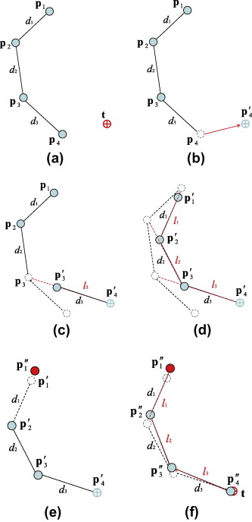

Figure 3.2‑2: Visualisation of FABRIK [21]

In addition to solving IK using DH parameters, the Unified Robot Description Format (URDF) has gained popularity as it contains more parameters. A URDF is an XML file and is especially popular with Robotics Operating System (ROS) users. URDF files contain elements like <links>, <joint>, <inertia> and many other elements. These elements can be loaded into simulators such as Gazebo or Pybullet, which could simulate the environment and forces while solving inverse kinematics equations. An example UDRF file is as follows.

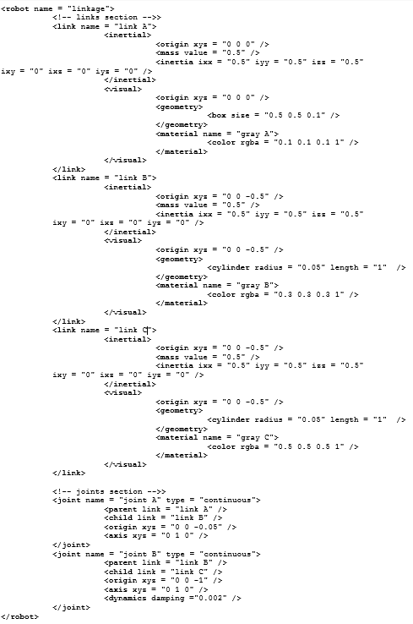

Figure 3.2‑3: XML URDF sample

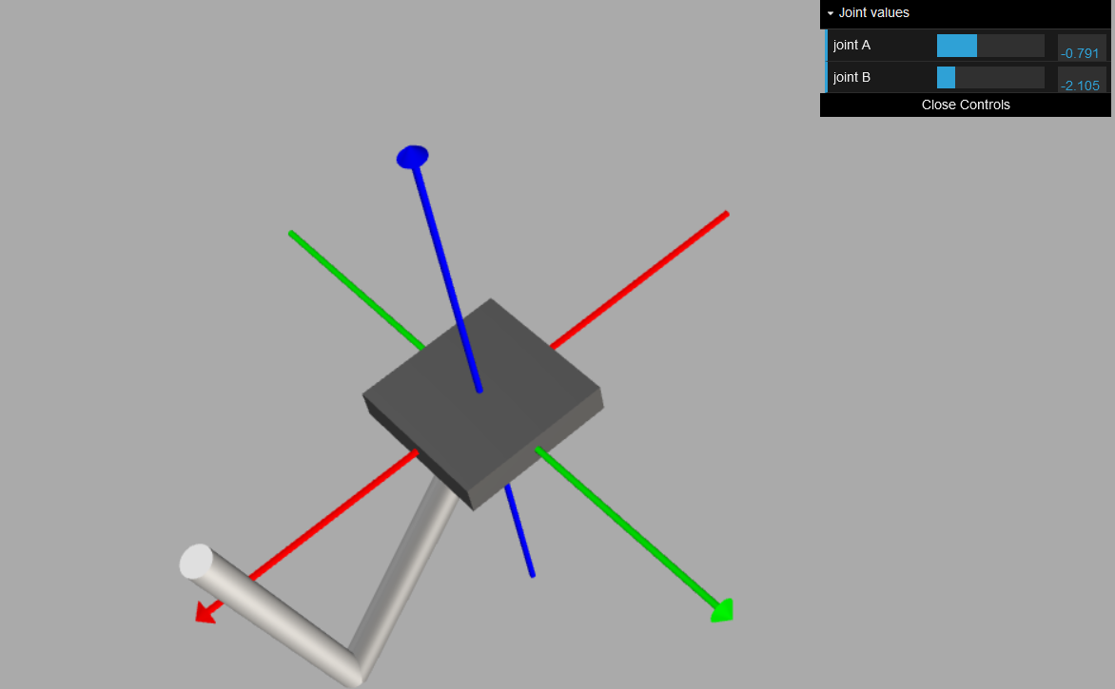

Figure 3.2‑4: Simulation of URDF Model

# Unmanned Aerial Vehicle

By implementing a UAV to deliver the projectile, the workspace of the UAV can be greatly extended resulting in a long-range, full 6 DOF system. Generally, there are 4 categories of UAVs. The drones consist of a flight controller where it collects data from the inertia measurement unit (IMU) and performs sensor fusion while applying an Extended Kalman Filter (EKF), reducing noise. Control theory is then used to model the flight dynamics and a PID controller is used to maintain stability. Figure 3F show the various categories of UAVs.

|  |  |
| --- | --- |
| What Is A PID Controller And How It Works? - PLCynergy  Figure 3.3‑1: PID Controller [22] | Diagram  Description automatically generated  Figure 3.3‑2: Categories of UAVs [23] |

While fixed-wing UAVs have better flight efficiency, multi-rotor drones are selected due to the lower cost and better manoeuvrability. Fixed-wing UAVs require a runway to take off and have a much larger turning radius which would impede the performance of payload delivery. This is so as the UAV is unable to hover in place, resulting in the moment delivery of the payload.

Ardupilot is an open-source autopilot system where the various configuration of autonomous systems is supported. Firmware for Rovers, fixed-wing plants multi-rotors and copters are supported.

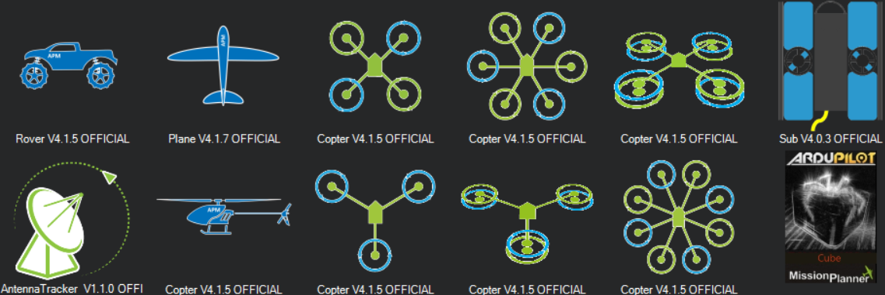

Figure 3.3‑3: Ardupilot Vehicle Firmware

To connect to a companion computer, MAVROS, a ROS package could be installed where the computer would be able to communicate with the flight controller over MAVLink. Where MAVLink is a messaging protocol where commands can be sent, and parameters can be received. This allows the standalone UAV to act as a goal-based agent where location data (state) can be stored and saved on the companion computer.

# Object Detection and Classification

To perform object detection and classification, the OpenCV package provides a real-time object detection model by finding contours in the image. By transforming the image into a greyscale image, a Canny edge detector would be used to retrieve the contours. This is done by performing a gaussian blur of the image to reduce image noise. A Gaussian kernel is used to transform each pixel value by taking the weighted average values of surrounding pixels. Next, the gradient would be calculated using Sobel kernels. This produces an image that has the shape of the outlined contours. This is followed by non-maximum suppression, reducing the contours to a thin line. Lastly, double thresholding is applied, whereby pixels higher than the high threshold are flagged as strong and below the lower threshold is flagged as weak. Any other pixels will be decided by hysteresis thresholding. Resulting in an image with contours [23].

|  |  |
| --- | --- |
| Figure 3.4‑1: 5x5 Gaussian Kernel [24] | Graphing a Gaussian Kernel in 3-D | James D. McCaffrey  Figure 3.4‑2: 3D Plot of Gaussian Kernel [25] |

|  |  |  |  |  |
| --- | --- | --- | --- | --- |
| A collage of a person  Description automatically generated with medium confidence  Figure 3.4‑3: Orignial Image | A collage of a person  Description automatically generated with medium confidence  Figure 3.4‑4: Blurred Image after Kernel | Figure 3.4‑5: Image after Sobel Kernel | Figure 3.4‑6: Non-max Suppression | Figure 3.4‑7: Double Thresholding |

Instead of performing algorithms to perform object detection, a possible method would be using deep learning applications to detect and classify images. Deep learning architecture, convolutional neural networks (CNN) mimic the visual cortex of a human brain in the form of neurons and activation functions and weights.

Object detection works by drawing bounding boxes around objects of interest. However, the number of objects and bounding boxes are not known beforehand. Therefore, the length of the output layer is not constant. To bypass this issue, Region-Based CNN (RCNN) separates the image into 2000 regions based on a greedy algorithm that combines similar regions, warps the image to fit an input size and passes the image into a CNN for classification. This was the first case of a two-stage detector [27]. The drawbacks of RCNN are the long training time to classify 2000 regions and the greedy search algorithm does not learn which could produce bad regions [28].

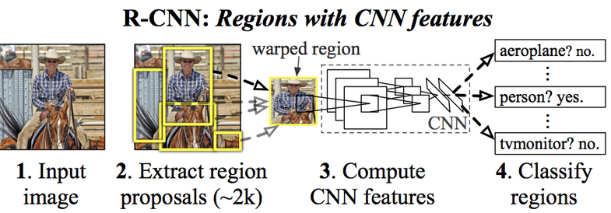

Figure 3.4‑8: RCNN Architecture

To solve this, Fast RCNN was developed. Instead of using region proposal, the image is fed to the CNN to obtain a feature map. Where the regions of the proposal are identified and warped into squares and fed into a fully connected layer. Thereafter, a software layer is used to predict the class of the proposed region. This reduces the number of region proposals, and the convolution is only done once per image to obtain a feature map [29].

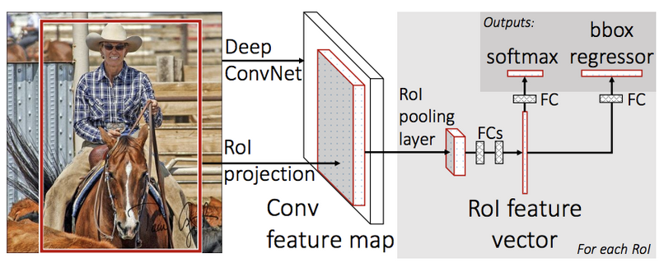

Figure 3.4‑9: Fast RCNN Architecture

Faster RCNN further improve the process by utilising an object detection algorithm to eliminate the search process which was the main bottleneck of the model. By using a separate network to propose the regions, the regions are reshaped and used to classify the image [30].

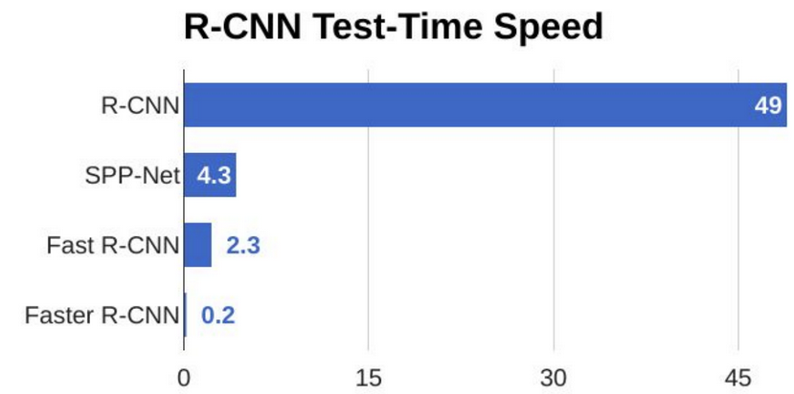

Figure 3.4‑10: Performance Comparison

Currently, the state of art object detectors like You Only Look Once (YOLO) and Single Shot MultiBox Detector (SSD) utilise a single stage detector. YOLO is based on an end-to-end convolutional neural network that predicts bounding boxes (object detection) and class probabilities at once (Object classification) [31]. Whereas SSD performs convolution for feature extraction, where a feature layer is obtained. These locations generate 4 bounding boxes, and a class score is calculated for each bounding box [32]. The highest score would be picked for each of the 4 bounding boxes. By having a single-stage detector, the performance is greatly improved and suitable for real-time applications.

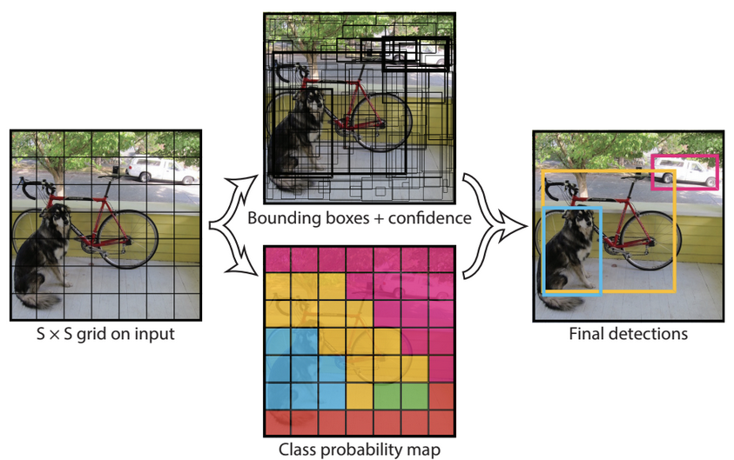

Figure 3.4‑11: YOLO Detection Model

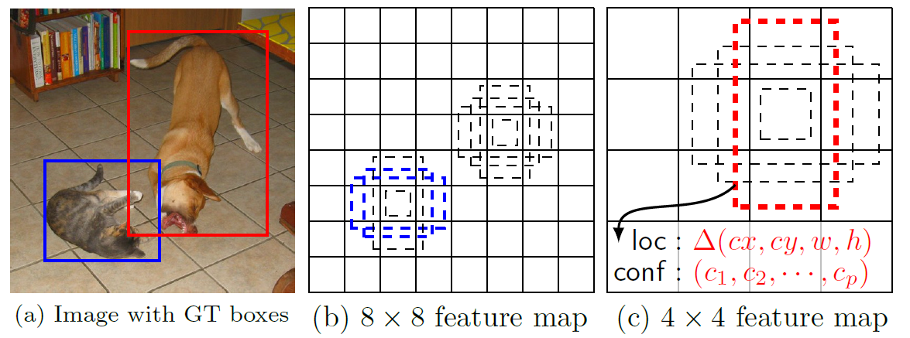

Figure 3.4‑12: SSD Detection Model

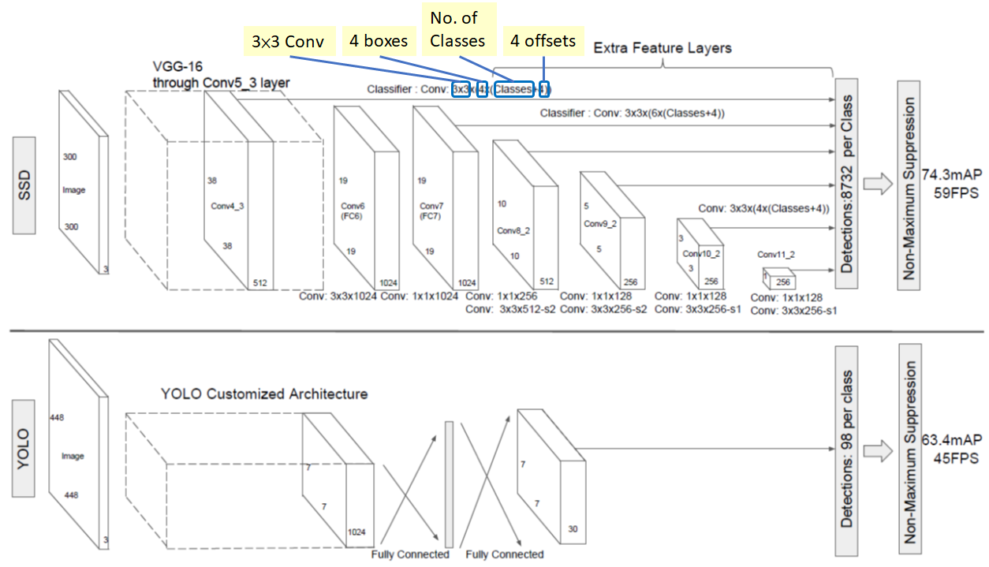

Figure 3.4‑13: SSD vs YOLO Architecture

# Users and Needs

The users of the project would be the RobotX 2022 team. Where the agent would deliver the racquetball to the required window. However, this project could also be deployed for usage in warehouses, where the agent would be able to perform picking and delivery of inventory. Where the needs of users are the accurate delivery of objects long distances.

# Functionality of Systems

To fully automate the process of object delivery, perception, mobility, and manipulation would be required. A further breakdown of the functionality is shown below.

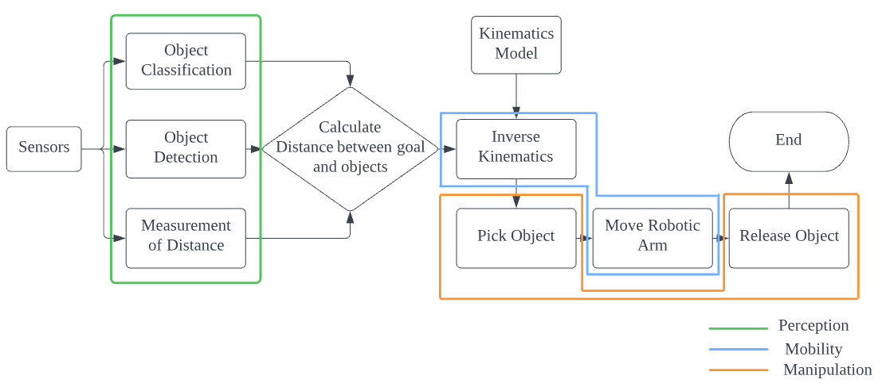

Figure 5‑1: Robotic Arm Functional Diagram

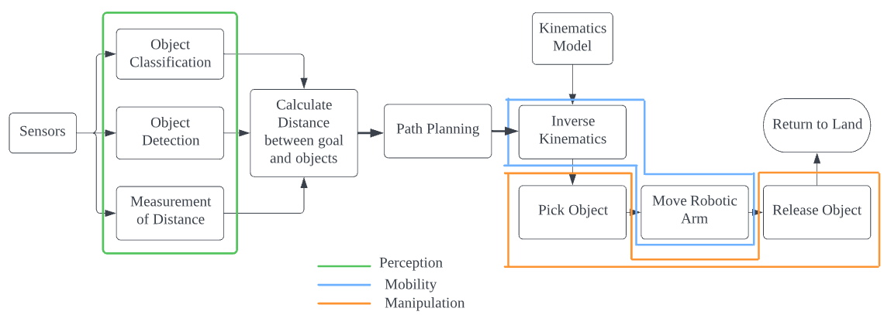

Figure 5‑2: UAV Functional Diagram

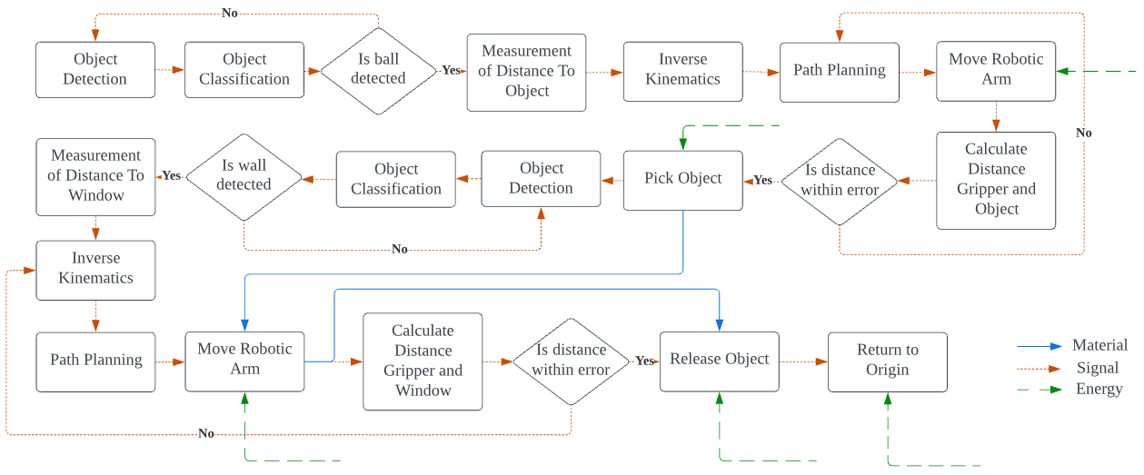

Figure 5‑3: Robotic Arm full process diagram

Firstly, the robotic arm system performs object detection and classification till the ball is detected. Once the ball is detected, a depth sensor measures the distance from the ball to the end effector, where the difference in X, Y, Z spatial are measured and fed into an inverse kinematics solver. By setting joint paths, the robotic arm would move closer to the ball and when the distance between the ball and arm is within a limit, it will attempt to pick the ball. Once the ball is picked, it rotates to search for the wall and window. Once again, the distance is calculated and IK is performed, this time moving the arm towards the window. When the distance is below the error threshold, the ball is released and retracted.

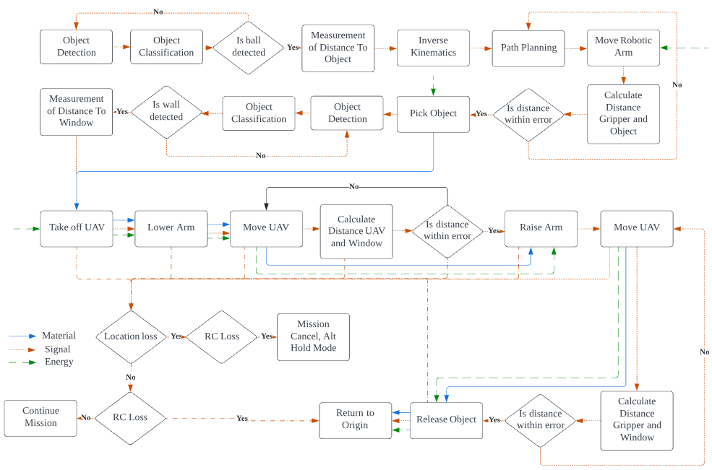

Figure 5‑4: UAV full process diagram

Firstly, the UAV performs object detection and classification till the ball is detected. Once the ball is detected, a depth sensor measures the distance from the ball to the end effector, where the difference in X, Y, Z spatial are measured and fed into an inverse kinematics solver. By setting joint paths, the robotic arm would move closer to the ball and when the distance between the ball and arm is within a limit, it will attempt to pick the ball. Once the ball is picked, searches for the wall and window. Once the wall is found, the UAV takes off. Upon reaching the intended altitude, it lowers the arm for higher stability and travels towards the wall. Once it reaches the first waypoint, the arms are raised, and the velocity is decreased. Thereafter the UAV attempts to minimize the error between the gripper and the window. Once, the ball cannot be seen, the gripper releases the ball moves backwards and then proceeds to land. At any time of the operation the UAV loses positional data, it will hover at its current altitude. If the UAV does not receive telemetry or radio control data for a set point of time, it cancels the mission and returns to land.

# Blueprint and Solutions

# Solutions to Functional Requirements

# Computer Vision

Computer vision is a field of study that allows the computer to infer meaningful information from digital images. When placed into an agent, it enables it to perceive and make a better decision by having additional information. An example would be an expert system where if-else statements can be fired based on perception from the cameras [33]. Solutions to computer vision include the OpenCV package, deep learning models like YOLO and SSD. Where the machine can perform object detection and classification.

# Depth Sensing

To measure depths, the simplest solutions include Time of Flight (ToF) sensors. Time of flight sensors measures the round trip distance from the emitter to receiver where the total distance travelled is twice that of the sensor. Sensors include ultrasound, lasers, infrared and radio wave sensors. By calculating the time from the pulse generation to receiving, the distance can be calculated based on the constant speed property of either electromagnetic or sound waves. Light detection and Ranging (LIDAR) sensors are also ToF sensors. By implementing an array of ToF sensors, LIDARS are capable of producing an accurate depth map of the surrounding.

|  |  |
| --- | --- |
| structured light sensor camera  Figure 6.1.2‑1: Time of flight Principle [34] | $$d=\frac{c*t}{2}= \frac{λft}{2}$$ $$where d:distance \\ c:speed of wave \\ t:time between emit and receive \\ λ:wavelenght of wave \\ f:frequency of wave$$ Equation 6.1.2‑1: Distance for ToF Sensors |

In addition to ToF sensors, computers could also perform depth sensing by mimicking humans. Humans perceive depth by binocular vision or stereopsis. For computers to perform this, a stereo camera setup is used, where the cameras are calibrated, where extrinsic and intrinsic parameters are retrieved. Next, an epipolar scheme is built using epipolar geometry. This allows us to build a disparity and a depth map.

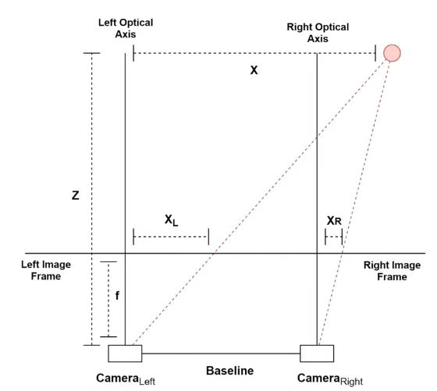

Figure 6.1.2‑2: MultiView Geometry - Disparity

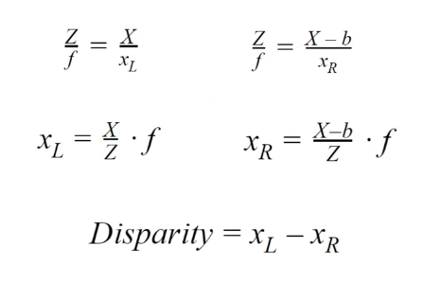

Equation 6.1.2‑2: Disparity Equations

# Motors and Actuators

To further facilitate mobility, the agent must have motors/ actuators to act on the environment. To control the robotic arm, motors are used to control revolute joints to allow the robotic arm to function as intended. The number of motors used would equate to the DOF of the robotic arm. Additionally, the gripper would require an additional motor to grasp and release the object. These motors should have a form of feedback to control the position of the robotic arm. Possible solutions include motors with rotary encoders, stepper motors and servo motors. To drive these motors, a suitable motor driver should be present to control the voltage, current and signal to control them. For the UAV, a suitable number of motor propeller sets are required for take-off and mission. Additionally, a set of motors would be required to control the robotic arms present on the UAV.

# Flight controllers

A flight controller is the brain of a UAV. It is usually a microcontroller (MCU) that performs the real-time computation required for stable flight. A flight controller usually contains a few sets of IMU where it contains accelerometers, gyroscopes, and magnetometers for redundancy. It also contains servo outputs to connect to electronic speed controllers (ESC)s where it controls the speed of the propeller for stable flight. The flight controller allows attaching of other components such as telemetry radio, radio controller (RC) receivers, Global Position System (GPS) receivers. With a flight controller, the UAV would be able to act as a level 2 autonomous agent. Whereby it would be able to provide stable vertical and horizontal positioning.

In addition to flying autonomously, a flight controller would be able to communicate to a ground control system (GCS) where all flight parameters would be updated in real-time, and the user would be able to start/end missions manually.

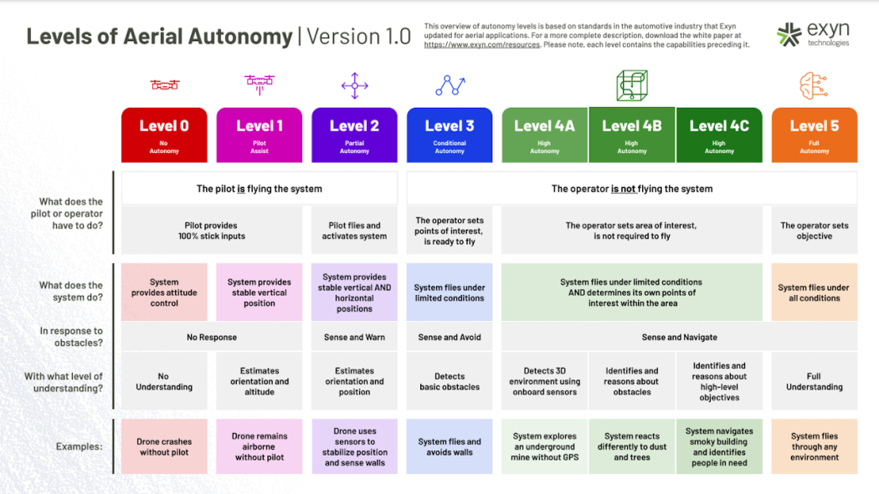

Figure 6.1.4‑1: Level of autonomous UAV [35]

# Companion computer

To increase the level of autonomy, a companion computer with the camera is added to perform object detection and classification and depth sensors to retrieve depth information as well as storing location states. This would enable the UAV to be a goal-based, utility agent. The companion computer would be responsible for the calculation of non-flight critical functions and providing inputs to the flight controller to fly like a level 3 autonomous agent.

# Other Solutions

Other solutions that are necessary but not critical for the operation of the platforms are listed together in the Table below.

|  |  |  |  |  |
| --- | --- | --- | --- | --- |
| Function | Solution | Options | | |
| A | B | C |
| Power System | Energy Source | Lithium Polymer | Lithium Ion | Power Supply |
| Step Down Power | Power Regulator | Battery Eliminator Circuit | Buck Converter | Linear Voltage Converters |
| Radio Controls | Radio Receiver | PCM Radio | PPM Radio | PWM Radio |
| Connection to Ground Control Unit (GCU) | Telemetry | Wi-Fi Telemetry | Radio Telemetry | Long Range Radio Telemetry |
| Support UAV components | UAV Frame | DJI F330 | DJI F450 | DJI F550 |
| Mobility of Robotic Arm | Degrees of Freedom | 4 | 5 | 6 |
| Mobility of UAV Arm | Degrees of Freedom | 1 | 2 | 3 |
| Controlling of Robotic Arm | Micro Controller | Arduino | STM32 | ESP32 |

Table 6.2‑1: Solutions for Auxiliary components

|  |  |  |  |
| --- | --- | --- | --- |
| Solution | Options | | |
| A | B | C |
| Object Detection and Classification | OpenCV | YOLO | SSD |
| Vision Sensor | USB Camera | MIPI DSI Camera | Wireless Camera |
| Depth Sensing | Ultrasound Sensor | Stereo camera | LIDAR |
| Motors and Actuators | Servo Motor | Motor with Encoder | Stepper Motor |
| Flight Controller | Wi-Fi Telemetry | Radio Telemetry | Long Range Radio Telemetry |
| Companion Computer | Raspberry Pi | Odroid XU4 | Jetson Nano |

Table 6.2‑2: Solutions to Primary Solutions

Once the possible solutions are generated, a morphological chart is generated to generate 2 possible ideas for the Robotic Arm and UAV.

|  |  |  |  |  |
| --- | --- | --- | --- | --- |
| Solutions | Combinations | | | |
| Robotic Arm 1 | Robotic Arm 2 | UAV 1 | UAV 2 |
| Object Classification and detection | OpenCV | YOLO | SSD | YOLO |
| Vision Sensor | USB Camera | Wireless Camera | MIPI DSI Camera | USB Camera |
| Depth Sensing | Stereo camera | LIDAR | Ultrasound Sensor | Stereo Vision |
| Motors and Actuators | Servo Motor | Stepper Motor | Motor With Encoder | Servo Motor |
| Flight Controller | NA | NA | Pixhawk Cube | Pixhawk 2.4.8 |
| Companion Computer | Jetson Nano | Raspberry Pi | Odroid XU4 | Jetson Nano |
| Energy Source | Lithium Polymer | Power Supply | Lithium Ion | Lithium Polymer |
| Power Regulator | Buck Converter | Linear Voltage Regulator | Battery Eliminator Circuit | Buck Converter |
| Radio Receiver | NA | NA | PWM | PPM |
| Telemetry | NA | NA | Wi-Fi Telemetry | Radio Telemetry |
| UAV Frame | NA | NA | F450 | F550 |
| Degrees of Freedom  (Arm) | 5 | 6 | NA | NA |
| Degrees of Freedom  (UAV) | NA | NA | 2 | 1 |
| Micro Controller | ESP32 | STM32 | Arduino | ESP32 |

Table 6.2‑3: Morphological Chart

# Concept Evaluations

To generate Pareto optimal solutions, a set of criteria and weightage are used to evaluate the functional solutions. Criteria are rated from 1 to 5, where 1 is the lowest and 5 is the highest. For the solutions, the criteria were cost, implementation simplicity, efficacy, weight, size, ease of use. The criteria are fully explained below.

**Costs** include the total amount of money spent on manufacturing, procurement of additional software. Cheaper costs will result in a higher return on investment (ROI) system where users will be more willing to adopt the solution for their use.

**Implementation Simplicity** includes the total amount of time spent on manufacturing, assembly and writing software. Having simpler solutions results in systems that are less complex which will result in faster implementation and lesser errors. Thus, making users more willing to utilise the solution.

**Efficacy** is the ability to reproduce the desired outcome. Having a highly accurate and effective system, the task can be completed most of the time. Thus, by having reliability, users would be able to have their problems solved.

**Weight** is the payload of the system. Having a lighter system, lesser power would be used to move the system and a lesser supporting structure for the system would be required. Thus, by having a lighter system, the payload of the USV can be used for other purposes.

**Size** is the footprint of the system. Having a smaller system, the spacing for the USV can be fully utilised allowing more devices to be packed. Thus, by having a smaller system, the space of the USV can be used for other purposes.

**Ease of use** is how simple the system is to operate. Having a simple operating system, the users will have lesser user inputs, where lesser mistakes are made, and the overall experience is improved. Therefore, having the problem solved with minimal effort. Making the solution attractive to users.

|  |  |  |  |  |  |
| --- | --- | --- | --- | --- | --- |
| Criteria | Weightage | Robotic Arm 1 | Robotic Arm 2 | UAV 1 | UAV 2 |
| Costs | 25% | 4 | 3 | 4 | 3 |
| Implementation Simplicity | 20% | 4 | 3 | 3 | 4 |
| Efficacy | 15% | 3 | 4 | 3 | 4 |
| Weight | 15% | 3 | 2 | 4 | 4 |
| Size | 15% | 3 | 2 | 3 | 3 |
| Ease of use | 10% | 4 | 4 | 4 | 4 |
|  | Total | 71% | 59% | 70% | 72% |

Table 7‑1: Scoring of Morphological Concepts

Based on the concept evaluation table, Robotic arm 1 and UAV 2 has the highest score of 71% and 72% respectively. These designs are chosen to be the final design concept and developed further.

# Design of Robotic Arm

The design of the robotic arm is based on an open-source project from How To Mechatronics [36], where parts are modified to fit the project. The robotic arm is a 5 DOF robotic arm. By having 1 lesser degree of freedom, it results in a robotic arm that can reach within its workspace. However, it lacks the capability of having orientation. Since the project only requires the object to be delivered into a window, where the location will be near the max range of the robotic arm, 5 DOF will be sufficient in delivering the payload. Additionally, it reduces the complexity of the arm resulting in lower cost, weight, and size.

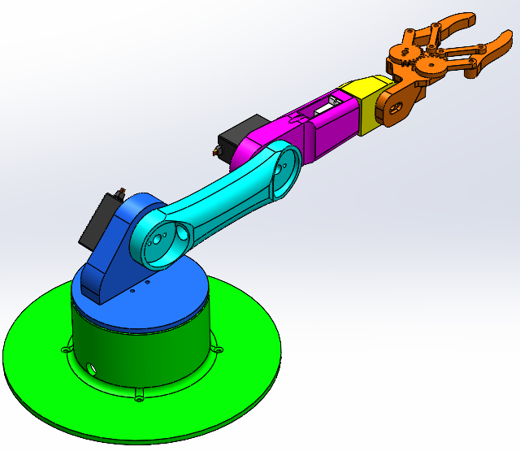

Figure 7.1‑1: 5DOF Robotic Arm

The robotic arm has an overall length of 330mm and is controlled by an ESP-32S microcontroller. Each of the joints is controlled by servo motors where MG996R is used for the first 3 joints, where a stronger motor is required. The last 2 joints use SG90 where the requirement of the motors is lower. Each of the servo motors has a 180˚ range. The entire robotic arm was 3D printed using Polylactic Acid (PLA) at an infill ratio of 40%. This method of rapid prototyping saves time, allowing more time to be spent on the mission-critical components.

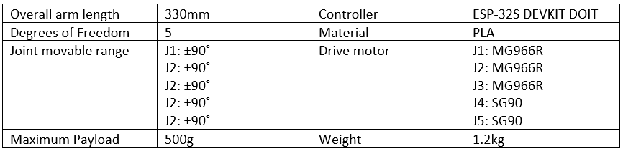

Table 7.1‑1: Specification of Robotic Arm

To check if motors are sized correctly, a simple spreadsheet is used to input the parameters of the robotic arm. These include the link length and mass, and the load the end effector carries.

$$\sum{T}=Iα$$

$$T_{motor}=Iα+T_{moments}$$

$$T_{motor}=\sum_{0}^{i}{I_{i}α_{i}}+\sum_{0}^{i}{m_{i}gd_{i}}$$

$$T_{motor}=\sum_{i=0}^{i}{\frac{1}{3}{m_{i}L_{i}^{2}α}_{i}}+\sum_{i=0}^{i}{m_{i}r_{i}^{2}α_{i}}+\sum_{i=0}^{i}{m_{i}gr_{i}}$$

$$Where m:Mass, L:Lenght, r:distance,g:gravity, I:moment of inertia$$

$$Where α:angular acceleration$$

Equation 7.1‑1: Motor Torque Sizing

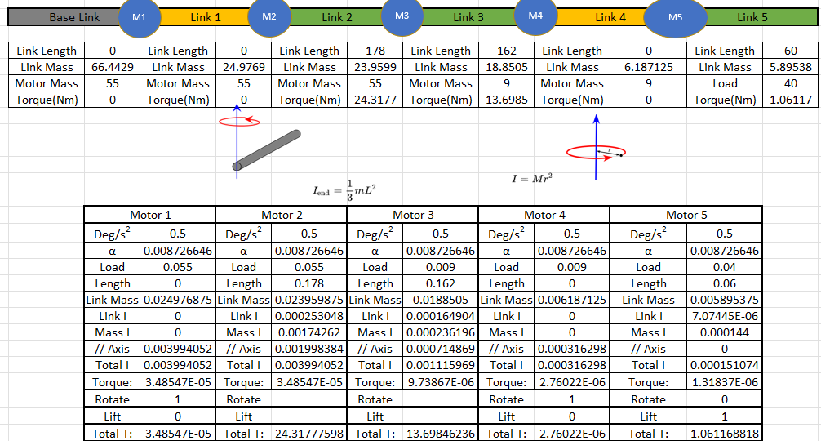

Table 7.1‑2: Sample Calculation of Motor

To generate the URDF model for the IK solver, SolidWorks UDRF exporter is used to generate meshes and parameters for it to be used. Firstly, the link and joint names are entered. The joint type is defined, and child links are added to the tree.

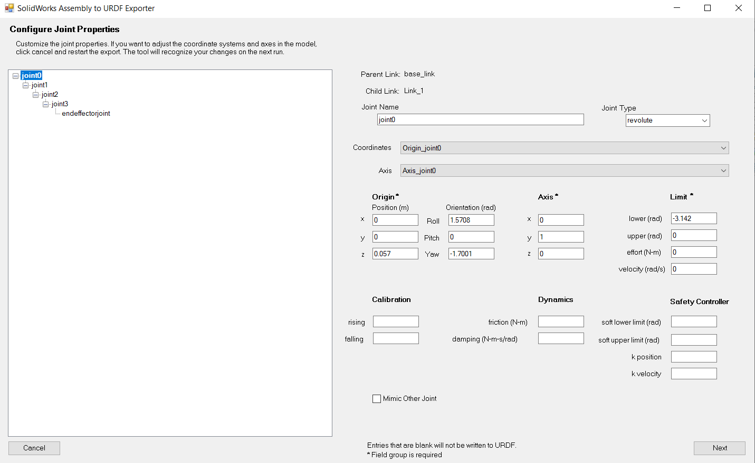

Figure 7.1‑2: Exporting Joint Properties

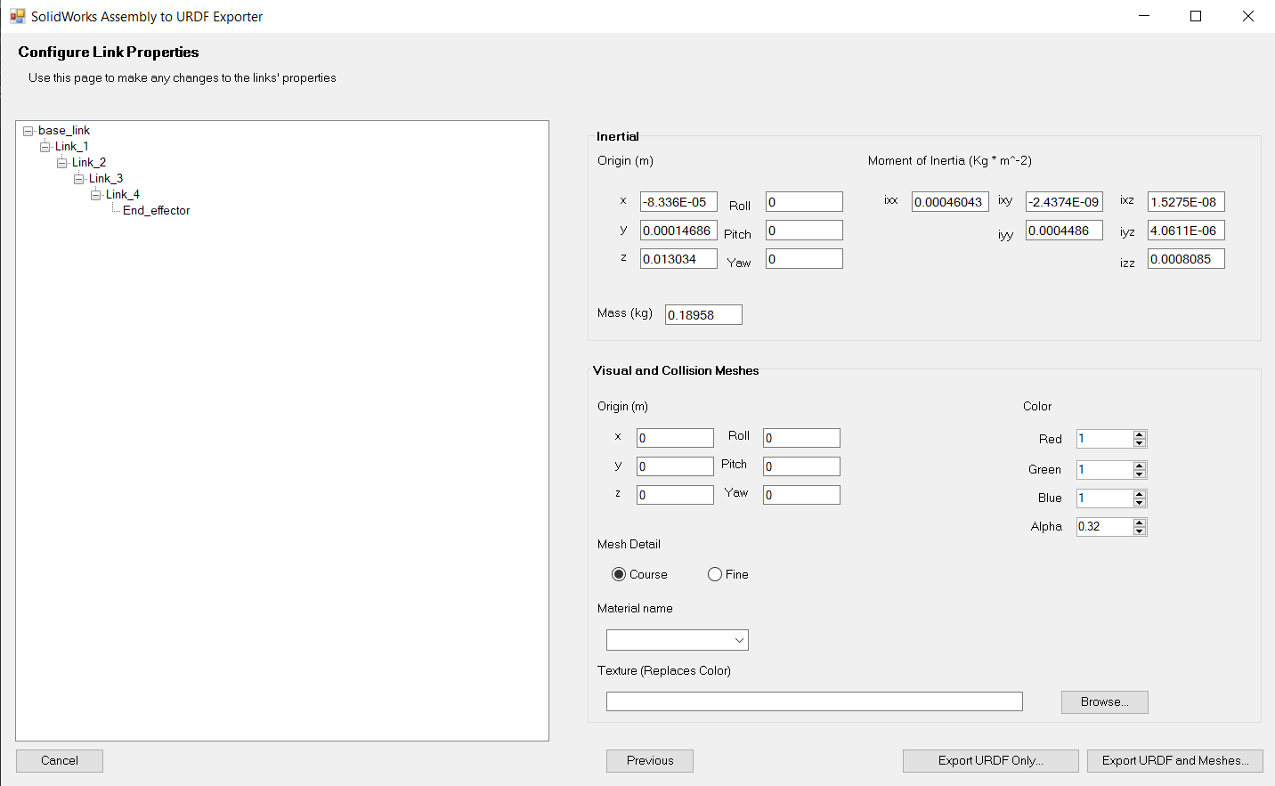

Figure 7.1‑3: Exporting Link Properties

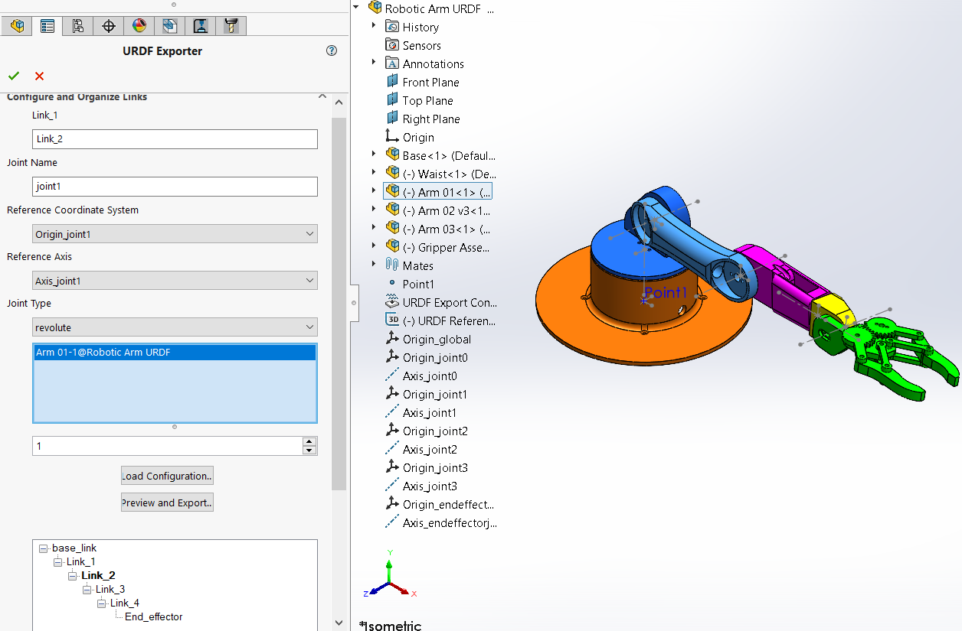

Figure 7.1‑4: Setting up URDF Definitions

# Interfacing of Robotic Arm

Once the URDF files are complete, it is loaded to PyBullet. By running PyBullet, a physics engine for simulation, Inverse Kinematics is calculated based on the input URDF model, constraints, and desired coordinate. To solve inverse kinematics, an optimisation process minimises the error between the desired position and the position of the end effector. By applying forward kinematics, the iteration of joint angles is used to calculate the position of the end effector. This process continues till the solution converges whereby the error is below a value of 1cm. The joint angles are then transmitted back to the ESP-32, and the MCU sends the signal over I2C to the servo driver, and the servo driver drives the servomotor, which controls the robotic arm. Within each servo motor, there is a closed-loop controller where a feedback potentiometer is used to control the angle of the motor.

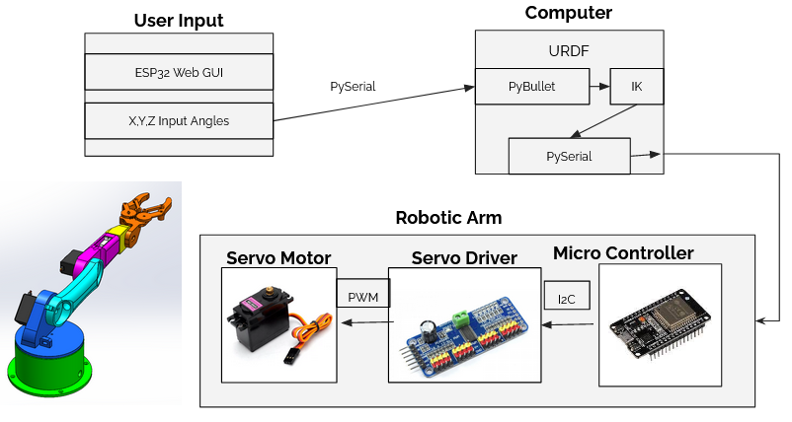

Figure 7.2‑1: Interfacing of Robotic Arm

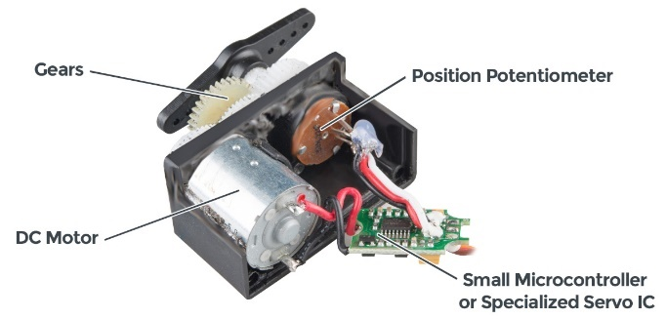

Figure 7.2‑2: Internals of Servo Motor

To test the system out, a web GUI was implemented to allow the user to control the robotic arm over the joystick. The (X, Y, Z) positional data is then fed over to a computer using PySerial communication. This facilitates the testing of the robotic arm over a simple joystick. Whereby individual modules are tested individually before combining to ensure functionality.

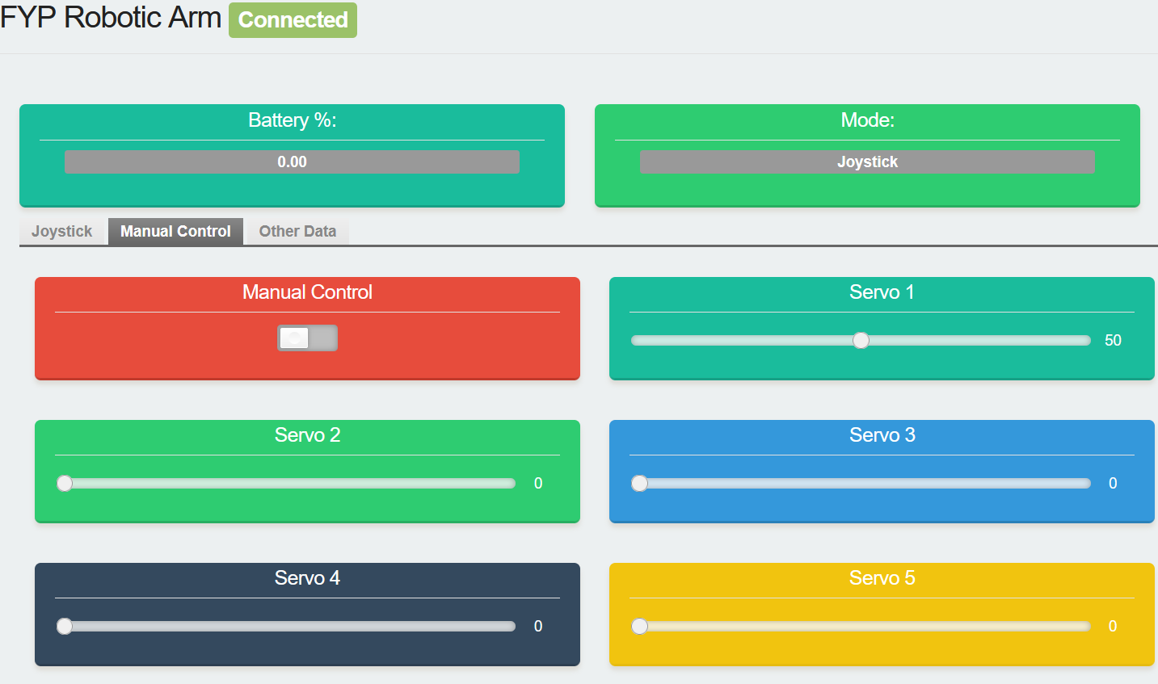

Figure 7.2‑3: Web GUI Manual Control Page

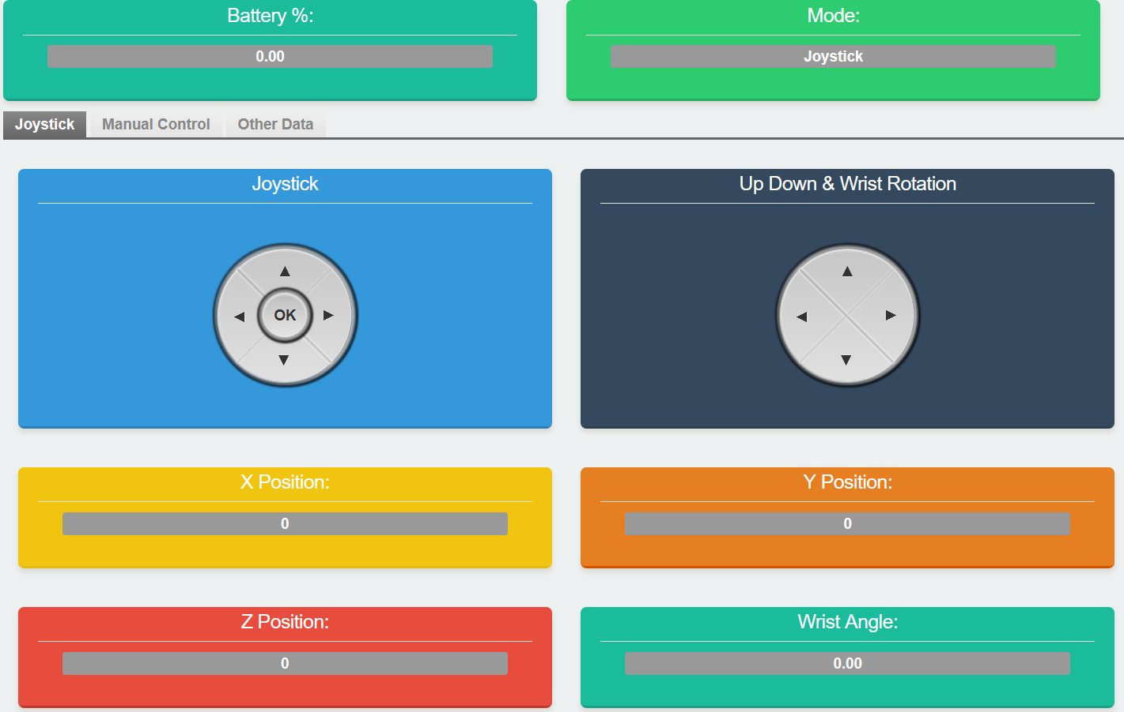

Figure 7.2‑4: Web GUI Joystick Control

# Design of UAV

The design of the UAV is based on the DJI Flame Wheel F550 Basic Kit. The frame is hex copter design where it would have sufficient thrust to carry the required components. Additionally, a modular 1 DOF robotic arm design will be added to the frame of the UAV, allowing it to deliver the object to the wall. The rationale of having a robotic arm is due to the under actuation of the UAV whereby the coplanar rotors are unable to provide a full 6 DOF body. Meaning that coplanar UAVs have thrust generated in the same direction and hence are unable to perform hovering on another axis. This would mean that a releasing mechanism would be insufficient to deliver an object through a wall as the plane of the wall is not parallel to the plane of the rotors.

|  |  |
| --- | --- |
| DJI - Official Website  Figure 7.3‑1: DJI F550 Frame | A picture containing boat, equipment  Description automatically generated  Figure 7.3‑2: Co-Planar UAV Thrust |

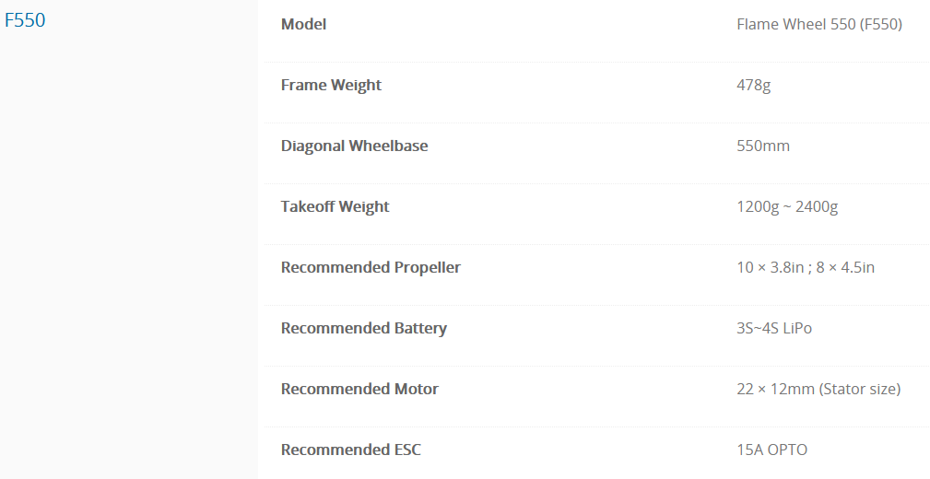

Figure 7.3‑3: Specification of F550 Frame

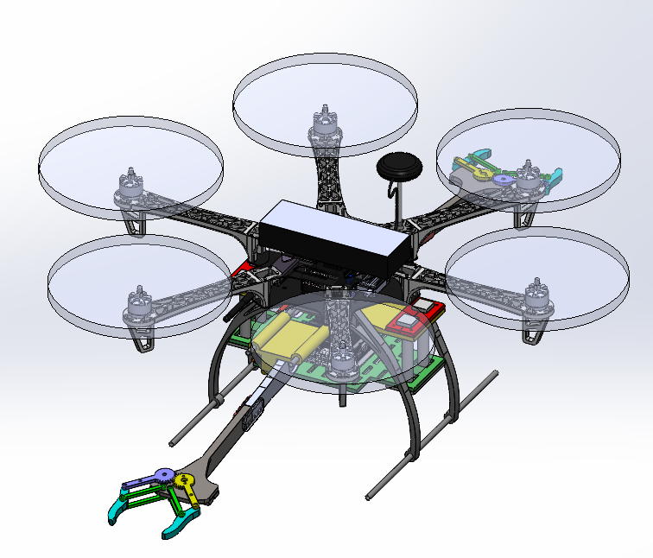

Figure 7.3‑4: CAD model of UAV

The design of the robotic gripper is a slide on the arm where it could be easily assembled onto the UAV gimbal slot for testing. The Robotic arm is 300mm long without the gripper. By having a longer arm, the clearance between the rotor blades and the wall is minimised. Whereby the rotor blade would not collide with the wall. The robotic arm consists of 5 parts and the gripper consists of 8. Due to the limited footprint of a 3D printer, the arm Link was decomposed from 1 part to 2 parts and another 2 parts were added to lock the links together.

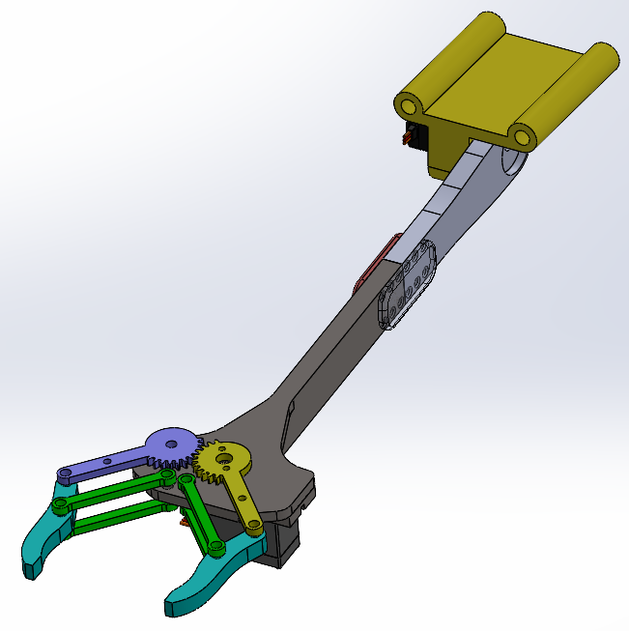

Figure 7.3‑5: Robotic Gripper Arm

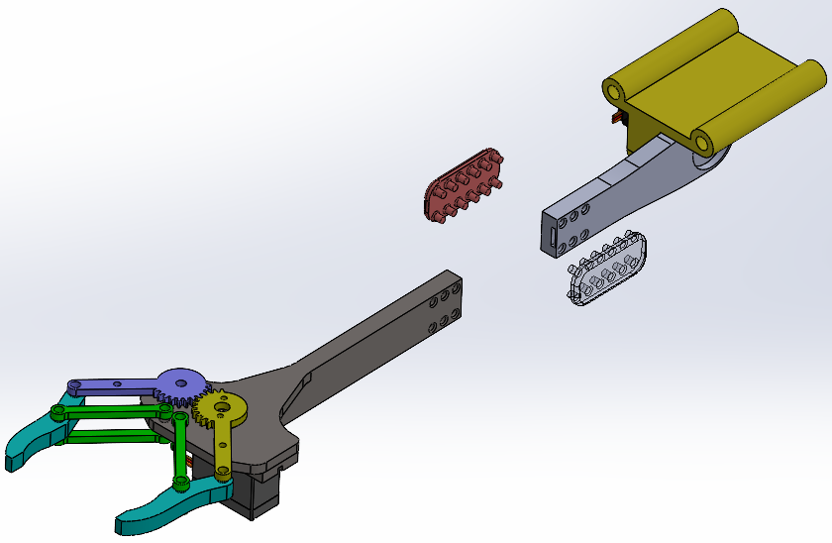

Figure 7.3‑6: Exploded Robotic Gripper Arm

To allow more electronics to be added to the UAV, an additional holder was designed to allow more items to be placed. The holder is to be 3D printed from PLA, where the model would be done in SolidWorks. The holder consists of 8 parts to reduce print time due to overhangs. The holder would be assembled and slotted onto the gimbal holder. The PLA rods act as dampeners for electronics placed on the holder. There are many cut-outs on the holder to allow for Velcro to secure the electronics.

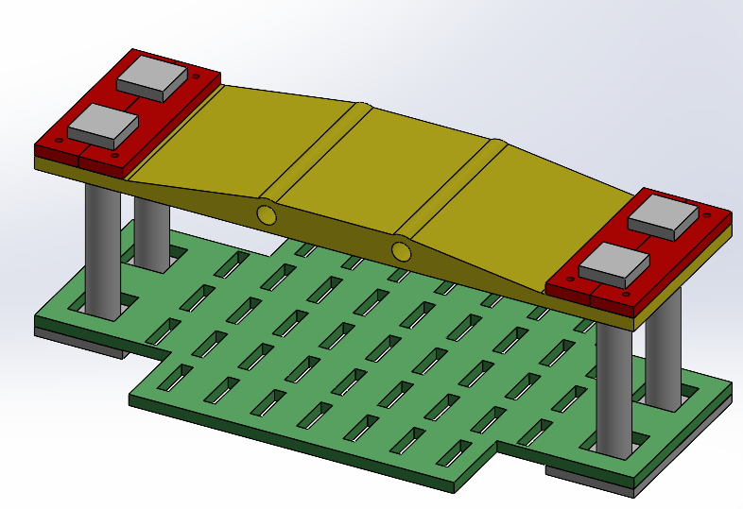

Figure 7.3‑7: Assembled Component Holder

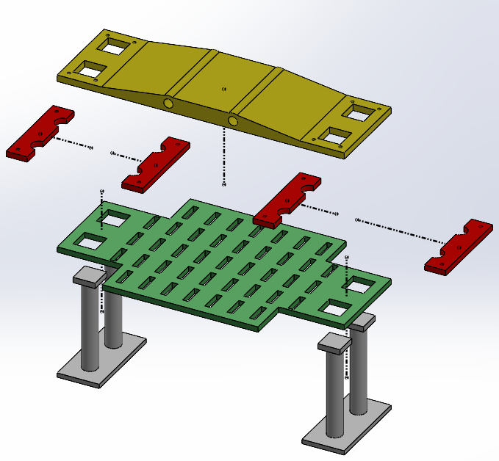

Figure 7.3‑8: Exploded View of Component Holder

# Interfacing of UAV

A computer works as a GCS where Mission Planner and Putty is installed. Putty is a free secure shell (SSH) and telnet client, where it would allow users to connect to computers within the same network over SSH protocol. The purpose of the computer is to monitor the UAV’s parameters to ensure that all parameters are functioning correctly.

The computer is connected to the flight controller over a telemetry radio by HolyBro where it offers a minimum of 300m range. Upon connection, the user would be able to calibrate the UAV’s compass, accelerometer and perform the take-off checklist.

The computer is connected to the companion computer, Jetson Nano over 802.11n Wi-Fi where the operating frequency of 2.4GHz offers a decent range of around 150m. Upon connection, a script is used to start the object detection and depth-sensing program.

The companion computer is connected to the flight controller USB whereby DroneKit, which uses MAVLink is used to communicate between the Jetson Nano and the Pixhawk 2.1 Cube. The Pixhawk uses the MAVLink protocol where serial is used to send data and commands between vehicles and ground stations. The companion computer would receive data from its stereo camera sensor to receive information about the surroundings.

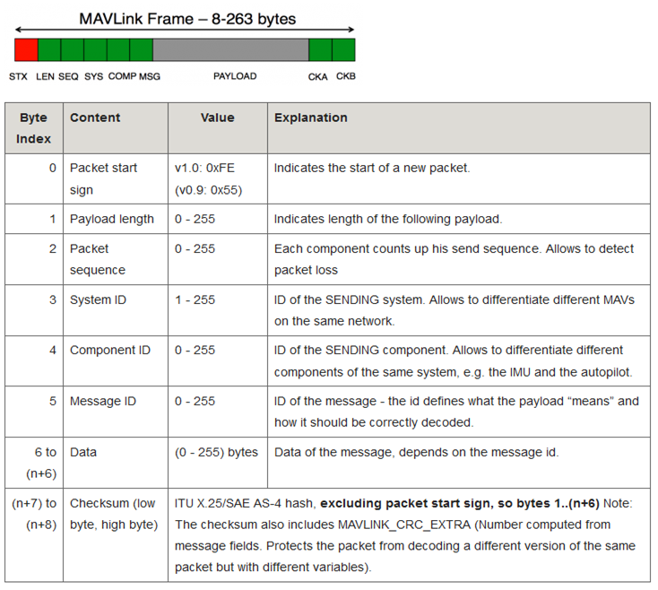

Figure 7.4‑1: MAVLink Message Format [37]

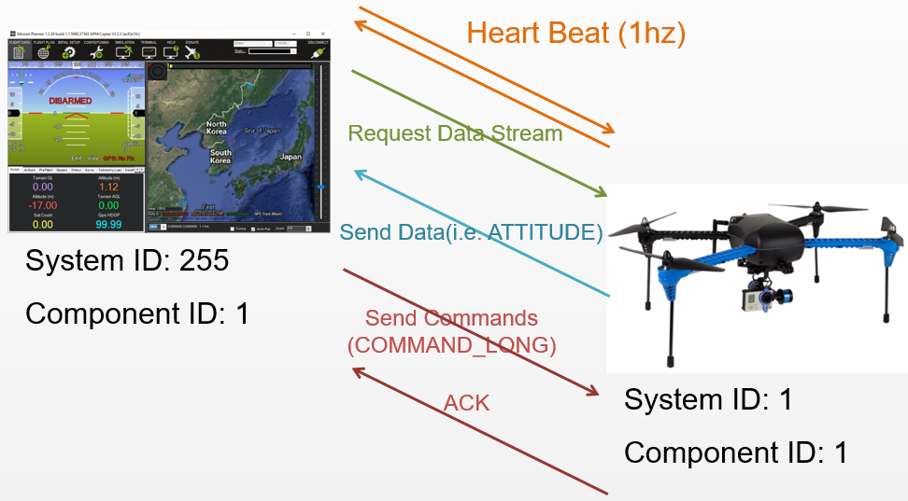

Figure 7.4‑2: MAVLink Message Flow [37]

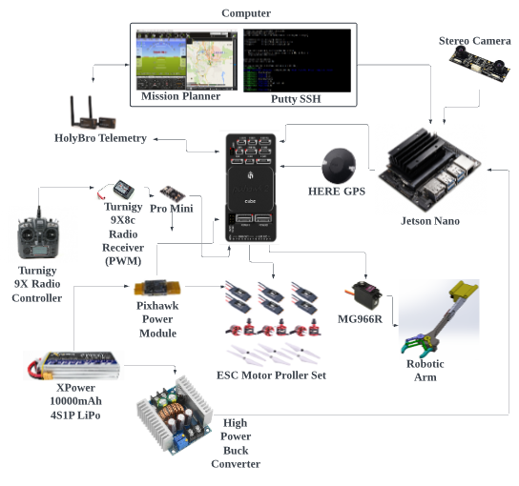

Figure 7.4‑3: Interfacing of UAV

# Simulation Analysis

The simulation analysis of the robotic arm would include stress analysis from SolidWorks and physics simulation on PyBullet where it would plan and travel to reach the required coordinate.

For the UAV, the simulation will be done in Mission Planner where the UAV would perform missions based on user/ companion computer inputs.

# Robotic Arm

The parameters of the analysis are 30N load and gravity. The material used is a custom PLA material whereby the first analysis includes Bucking analysis, where most of the stresses occur at the gripper. The arm is loaded into a position whereby it has the maximum range, where it would likely be operating and would be the worst-case scenario for the robotic arm.

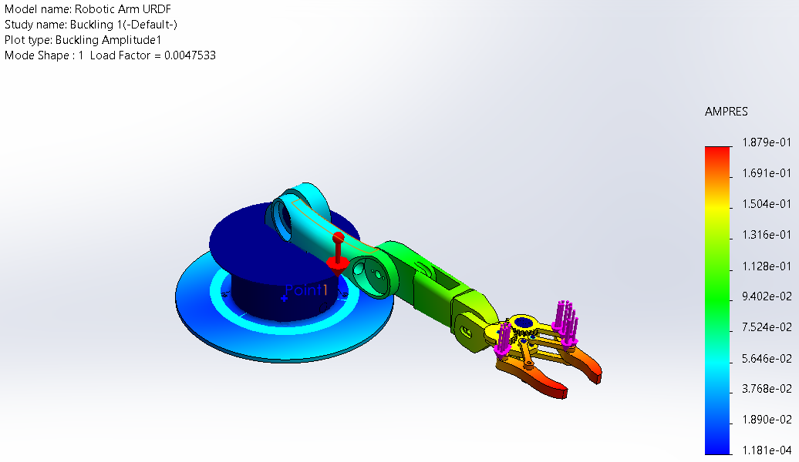

Figure 8.1‑1: Buckling Analysis of Robotic Arm

The first next analysis is based on failure analysis, whereby the material is tested for failure instead of structural buckling. Von Mises is used as the failure criteria. Based on the finite element analysis (FEA) the areas with the highest pressure are at the joints where the links are connected. The largest displacement occurs at the gripper and the strain is minimal. Based on the analysis, the robotic arm will be able to handle loads way above the designed load of 4N.

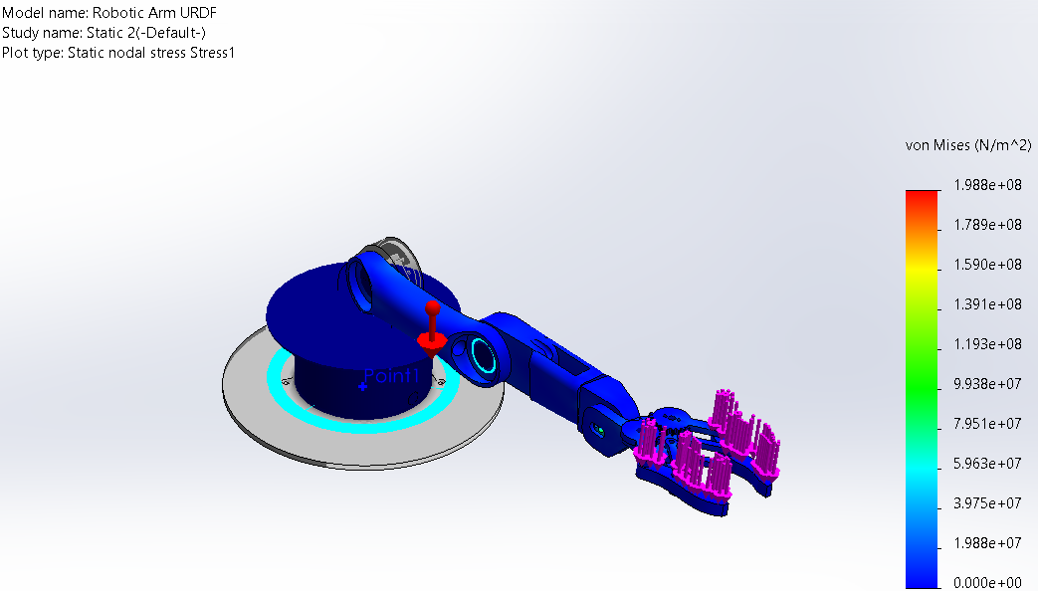

Figure 8.1‑2: Von Mises Analysis of Robotic Arm

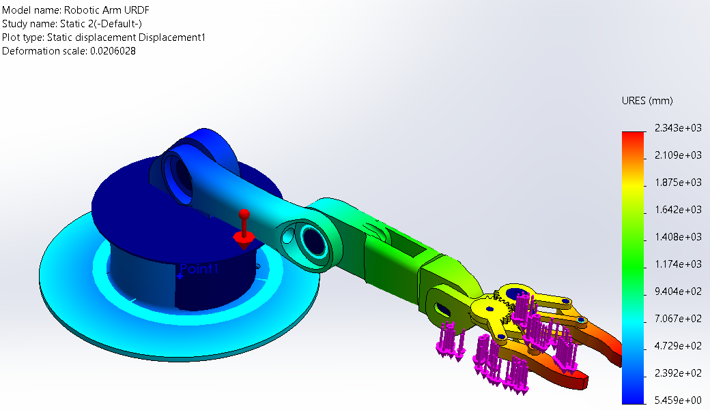

Figure 8.1‑3: Displacement Analysis of Robotic Arm

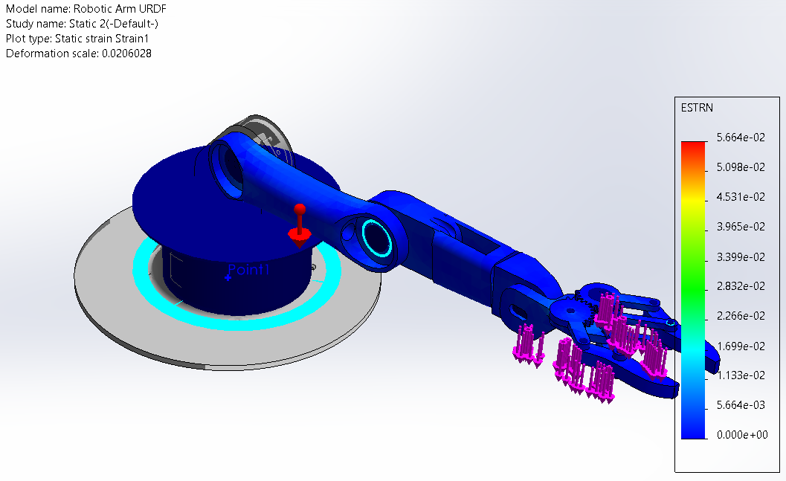

Figure 8.1‑4: Strain Analysis of Robotic Arm

The next simulation will be for the mobility of the robotic arm. Using PyBullet, the URDF meshes are loaded. An input coordinate is given to the robotic arm and the IK solver solves for the input angles to achieve the required position. By using a computer, this process takes less than a microsecond to converge. The angles are then used for the simulation of the robotic arm. The forces and velocity of the motor can be controlled allowing the arm to be able to react to disturbances. This would allow users to get a feel of how long the arm takes to travel to the intended position. With the simulation complete, the actual robotic arm can be tested.

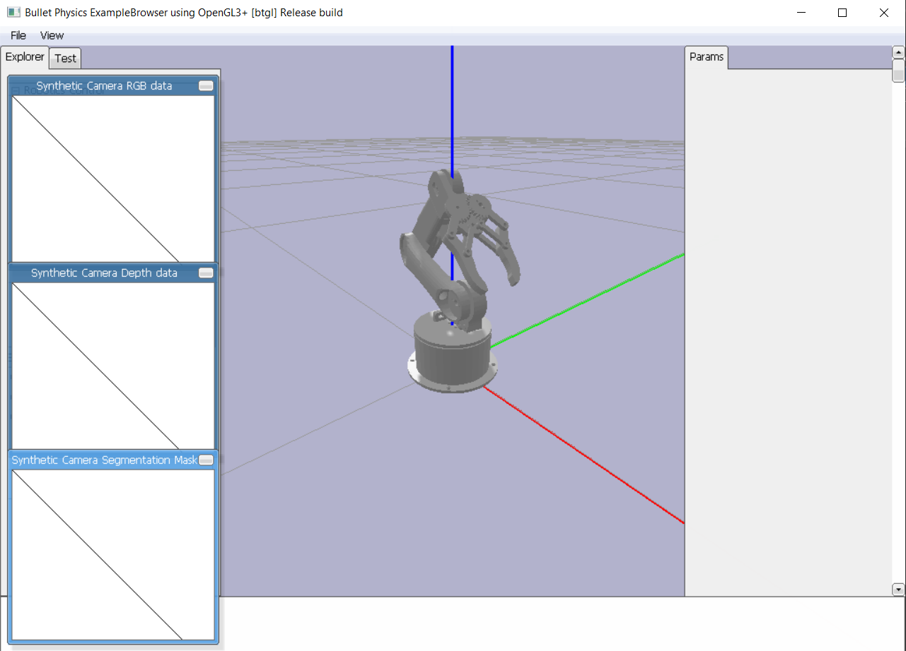

Figure 8.1‑5: Initial Simulation within PyBullet

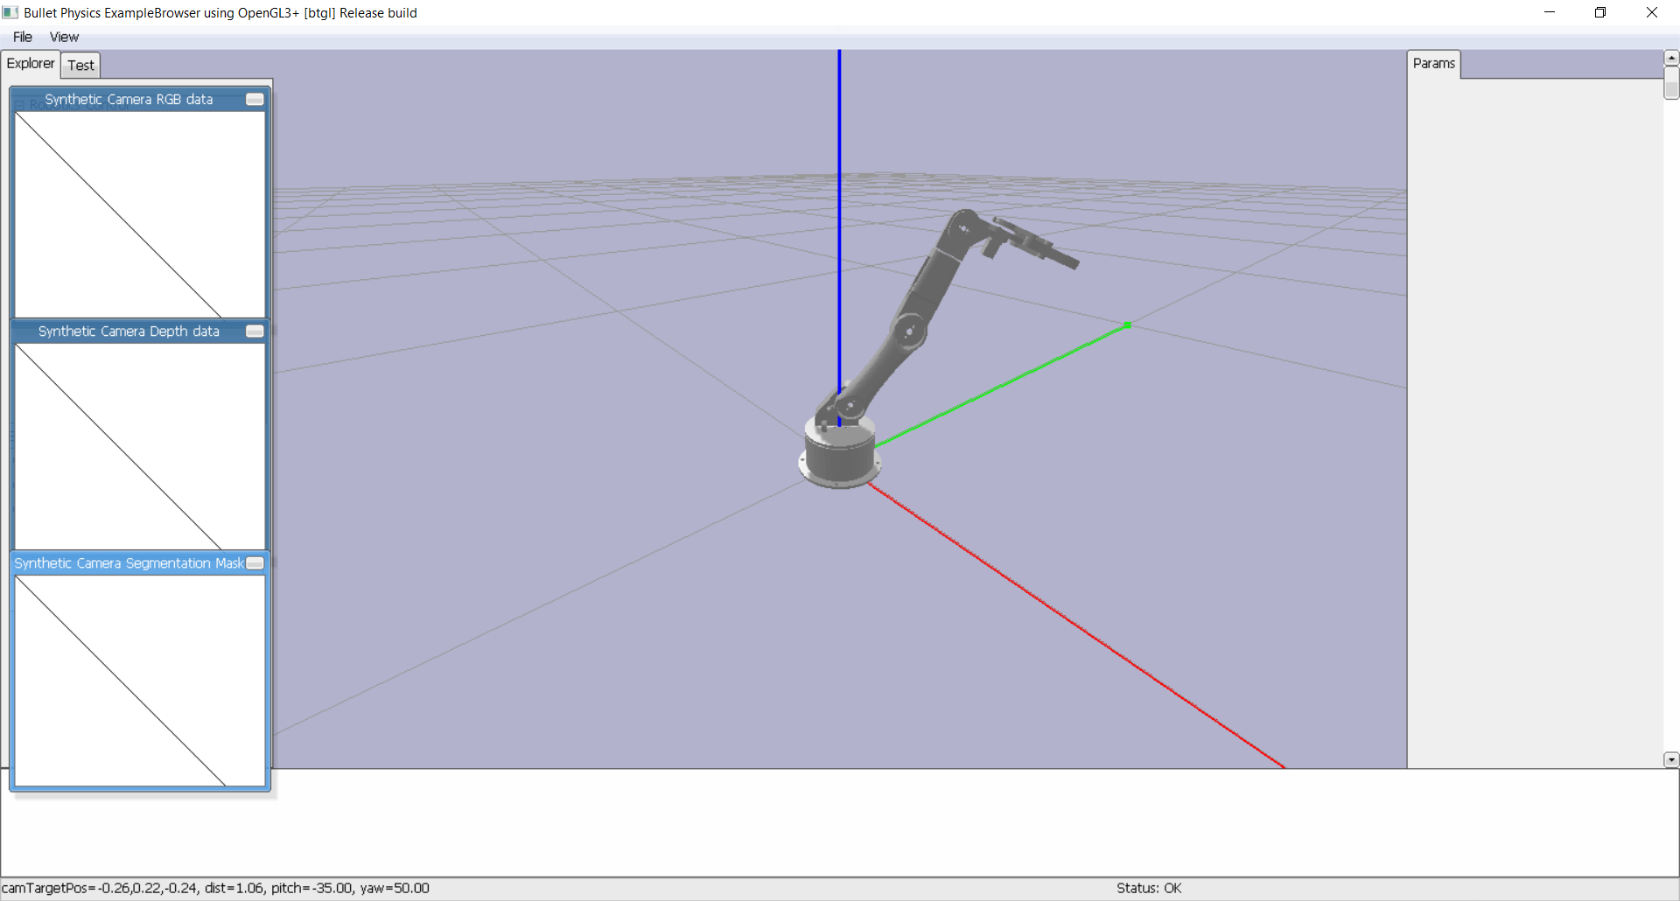

Figure 8.1‑6: Final Simulation within PyBullet

# UAV

To simulate the UAV, Mission Planner comes with a software in the loop (SITL) simulator whereby a flight dynamics model is used to simulate sensor data. The connection is made through TCP whereby the software simulates a vehicle connected to GCS over telemetry. The vehicles include rover, plane, multirotor and helicopter. To set up, a multirotor configuration of hex frame was chosen. To test the UAV, waypoints were manually planted based on the planner whereby a position and altitude were given a waypoint. The final waypoint would be a return to land (RTL) command. Thereafter, the mission is started, and the UAV would fly towards the waypoints. Once it reaches a set waypoint radius, the UAV moves towards the next waypoint. When it has reached the final waypoint, it returns to land. Additional testing is also possible whereby the user can simulate wind direction and speed to test the limit of their UAVs. Parameters such as EKF noise or RC fail can also be simulated to make the system more realistic.

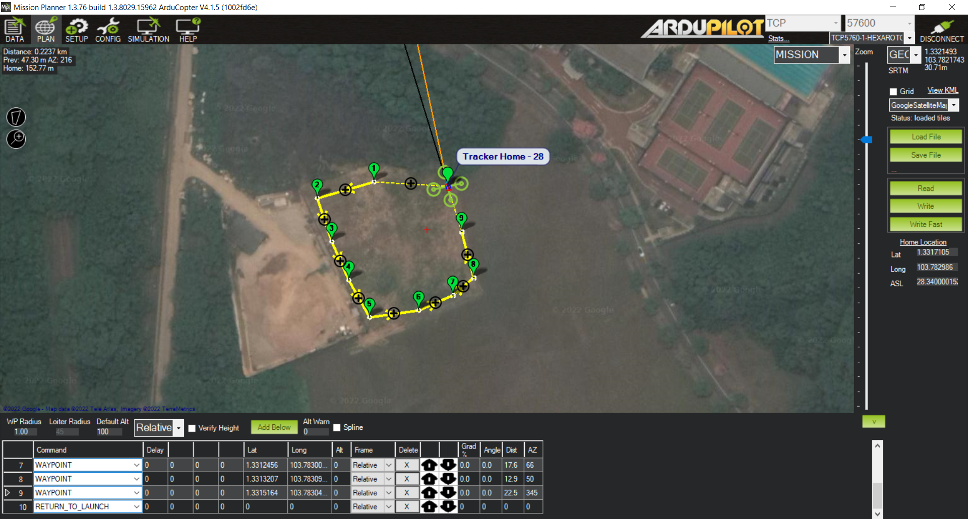

Figure 8.2‑1: Mission Planning on Mission Planner

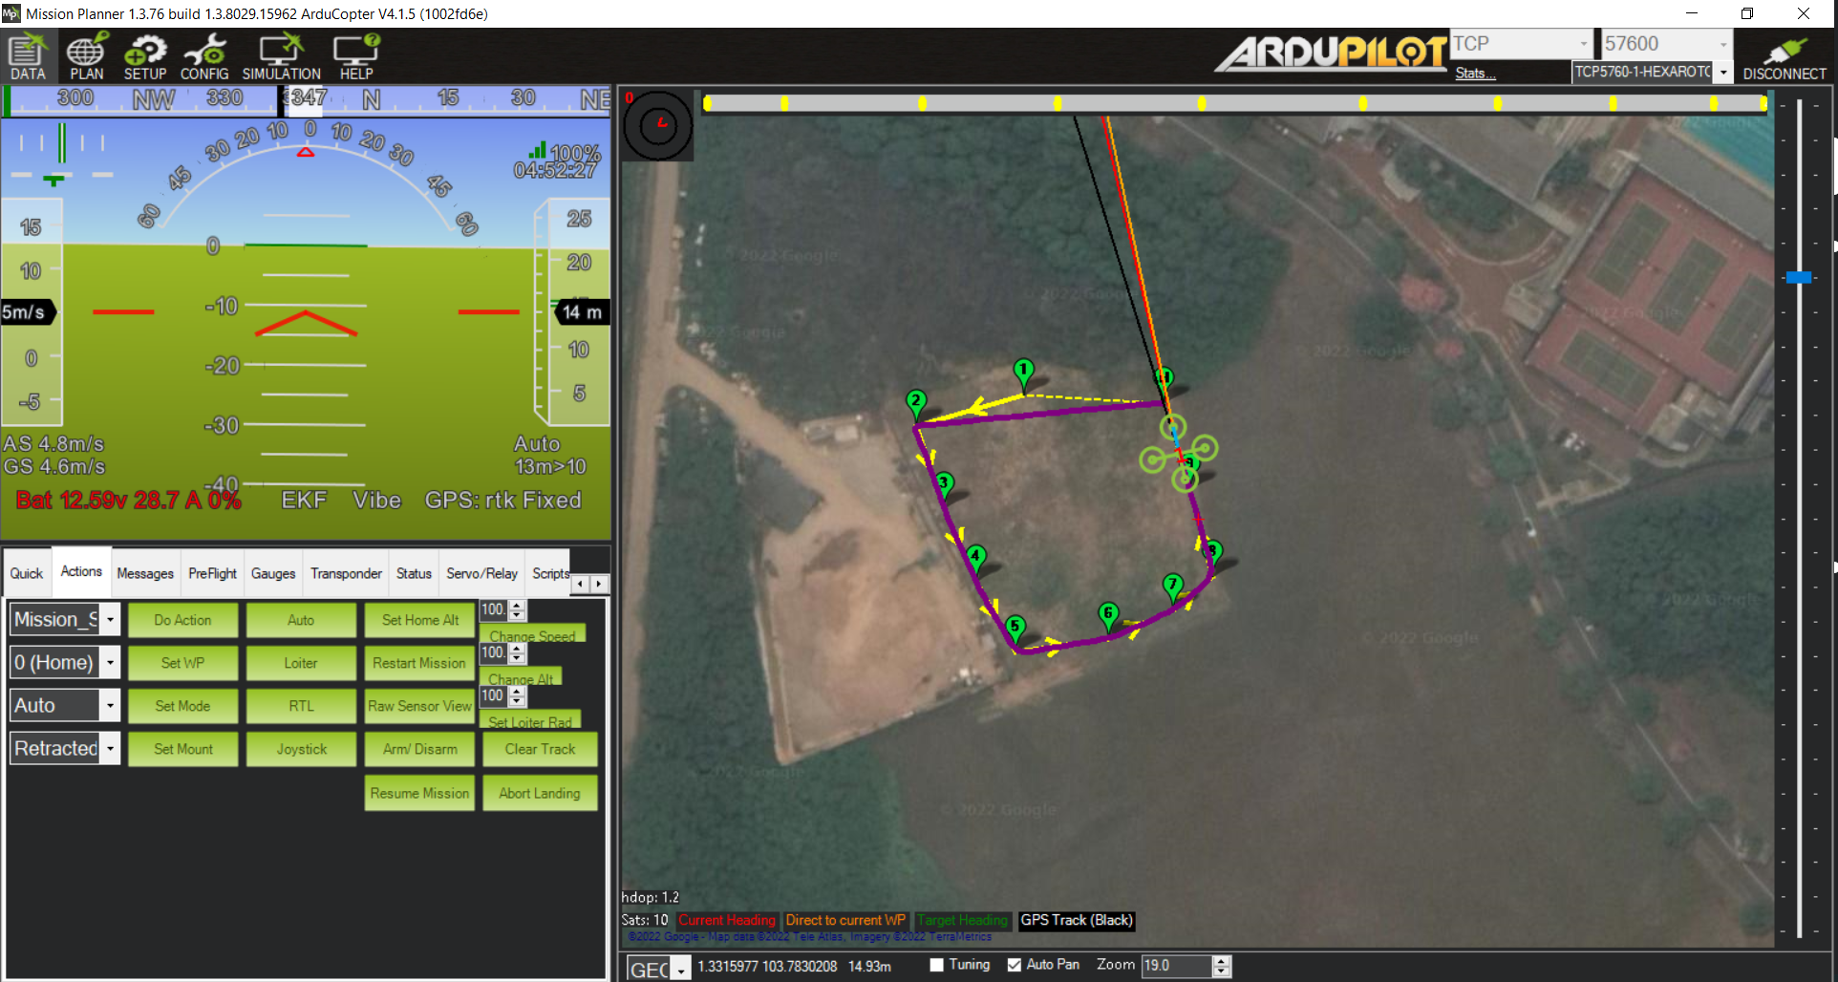

Figure 8.2‑2: Simulation of Flight Path

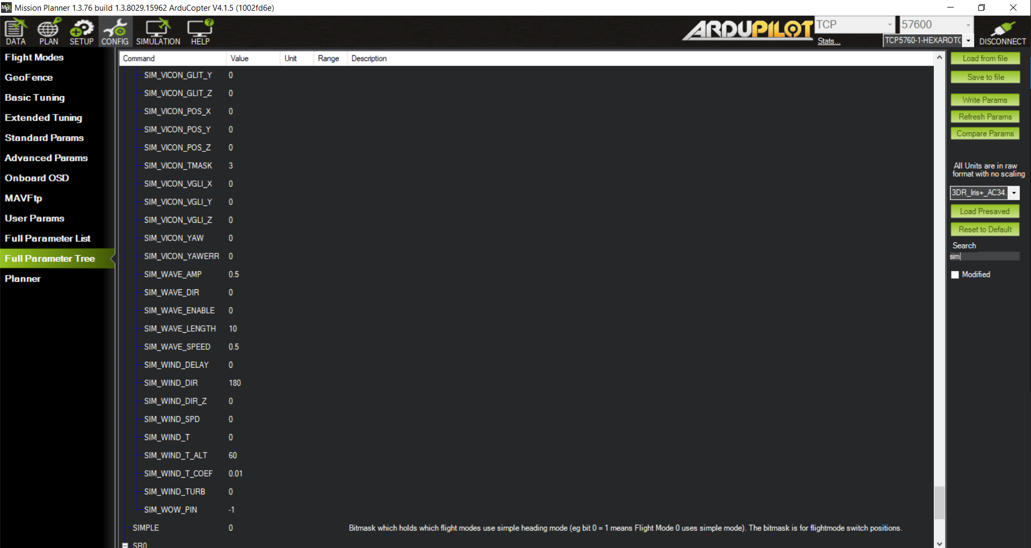

Figure 8.2‑3: Simulation Parameters

Once the testing of the UAV mission is completed, the simulation is connected over to the computer over the TCP port, whereby DroneKit runs and provides commands to the UAV. From DroneKit, the user would manually input commands for the UAV to follow. Commands include flying towards a known waypoint, speed control, velocity control. By having a script to generate waypoints, the UAV would be able to fly to waypoints relative to its current position.

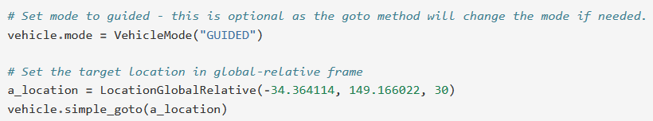

Figure 8.2‑4: Sample code for waypoint flight

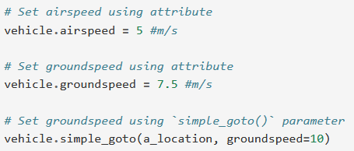

Figure 8.2‑5: Sample code for speed control

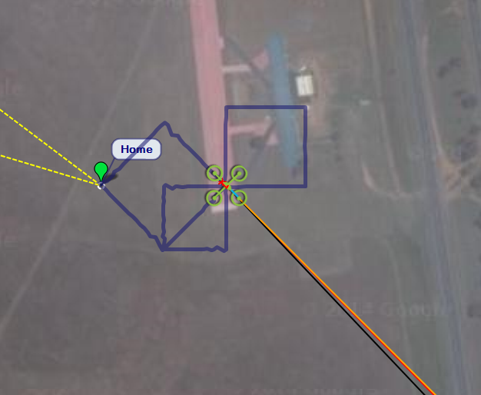

Figure 8.2‑6: Sample Flight from Companion Computer Data

# Actual Analysis

# Robotic Arm

The robotic arm was 3D printed using 40% infill PLA. The simple robotic arm consisted of 12 parts which were easy to print and assemble.

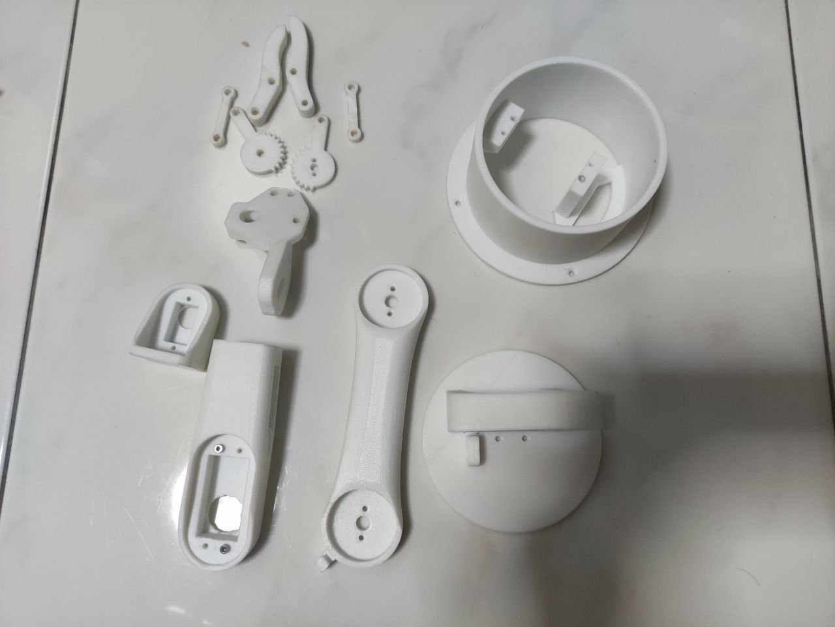

Figure 9.1‑1: 3D Printed parts of Robotic Arm

|  |  |
| --- | --- |
| Figure 9.1‑2:Electronics for Robotic Arm | A picture containing wall, indoor  Description automatically generated  Figure 9.1‑3: Motors for Robotic Arm |

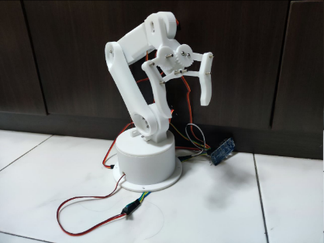

Figure 9.1‑4: Assembled Robotic Arm

To test the robotic arm, a joystick control controller on the ESP32 Web GUI is used to control the robotic arm position through software buttons. The robotic arm is used to pick up an eraser and the user controls the position of the end effector using the joystick, where joint angles are calculated over PyBullet.

|  |  |
| --- | --- |
| A picture containing indoor  Description automatically generated  Figure 9.1‑5: Initial Position of Arm | A picture containing indoor, cluttered  Description automatically generated  Figure 9.1‑6: Arm Performing Picking |
| Figure 9.1‑7: Arm Lifting Object | Figure 9.1‑8: Arm Releasing Object |

Based on the results, the capability of the robotic arm is satisfactory whereby it can travel based on coordinates, able to pick objects and deliver them. With the basic functionality completed, further experiments will be conducted with computer vision to complete the robotic arm system.

# UAV

The UAV is assembled from an F550 frame, with Pixhawk 2.1 as the flight controller and Jetson Nano as the companion computer. 6 30A ESC, 3 counter-clockwise (CCW) + 3 clockwise (CW) 2212 brushless dc motors (BLDC) from ReadyToSky and (3CW+3CCW) 9045 propellers from DJI is used. The ESCs are connected to the Pixhawk, with telemetry and GPS. Power is received from a power module that steps down the input power to 5V for the Pixhawk to use. 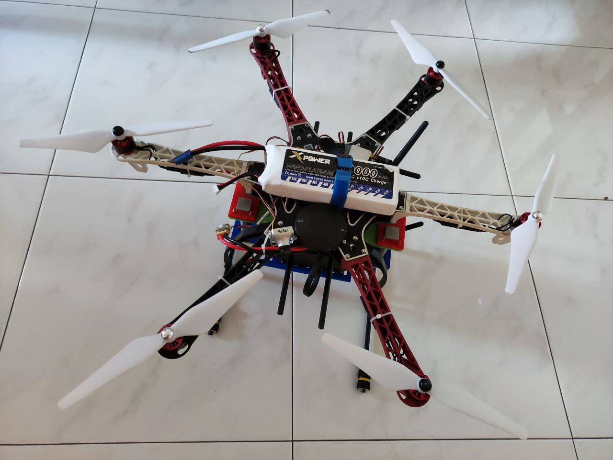

Figure 9.2‑1: Assembled UAV

To test the Pixhawk, an RC receiver is necessary to take over the UAV in cases of emergency. The Pixhawk takes in a pulse position modulated (PPM) signal for radio control. However, the exiting receiver uses pulse width modulation (PWM), which results in requiring 8 separate channels for each command. To solve this, an Arduino Pro mini is used to convert PWM into PPM for the Pixhawk. The received is opened for soldering and the small Arduino is fitted into the body of the RC receiver where 3 cables are routed out for connection with the Pixhawk.

|  |  |
| --- | --- |
| Figure 9.2‑2: Back of RC Receiver | Figure 9.2‑3: Top of RC Receiver |

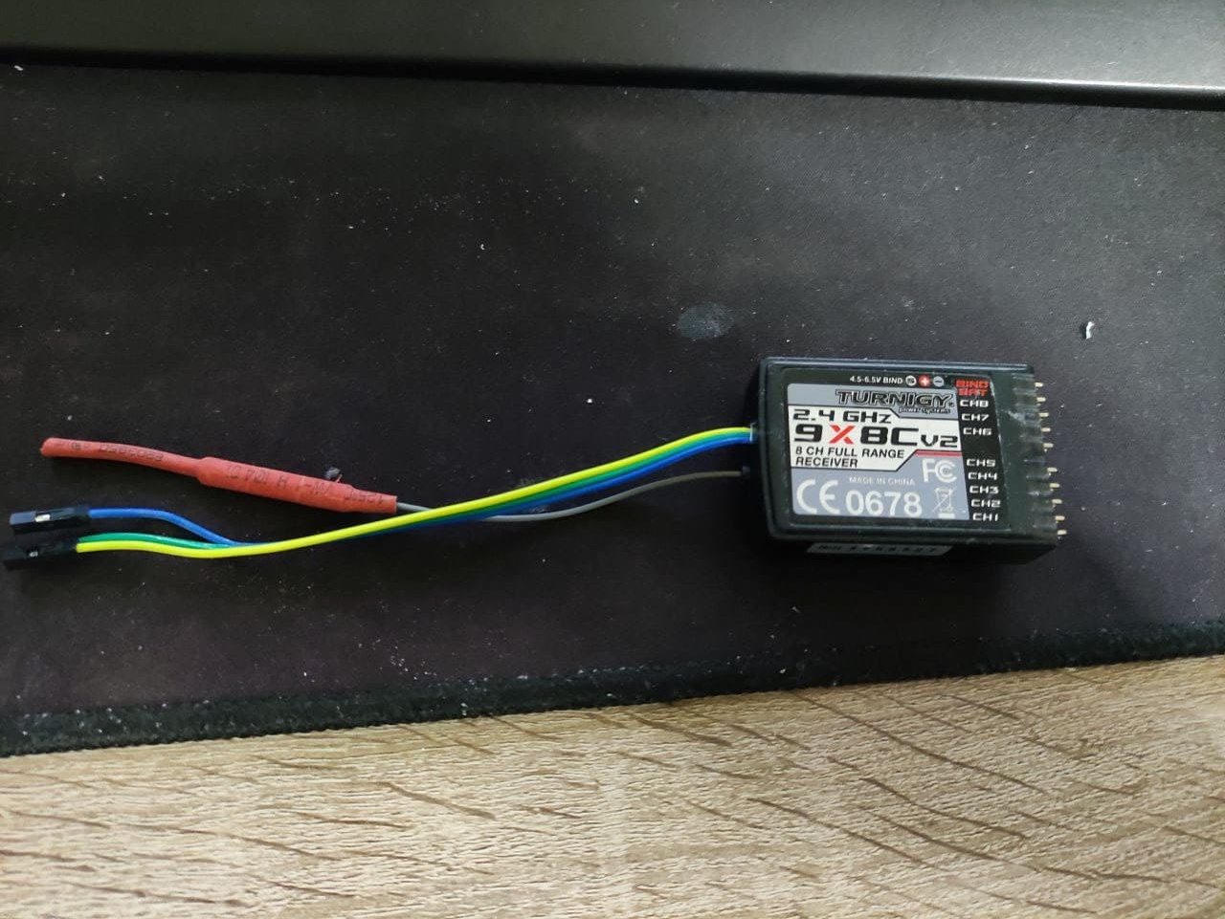

Figure 9.2‑4: Assembled RC Receiver

To set up the Pixhawk, radio, ESC, accelerometer, the compass is required to be calibrated. The Ardupilot software makes this process easy. To calibrate the RC, the user turns on the controller and start the calibration, moving between each extreme of each input where the min and max values are stored.

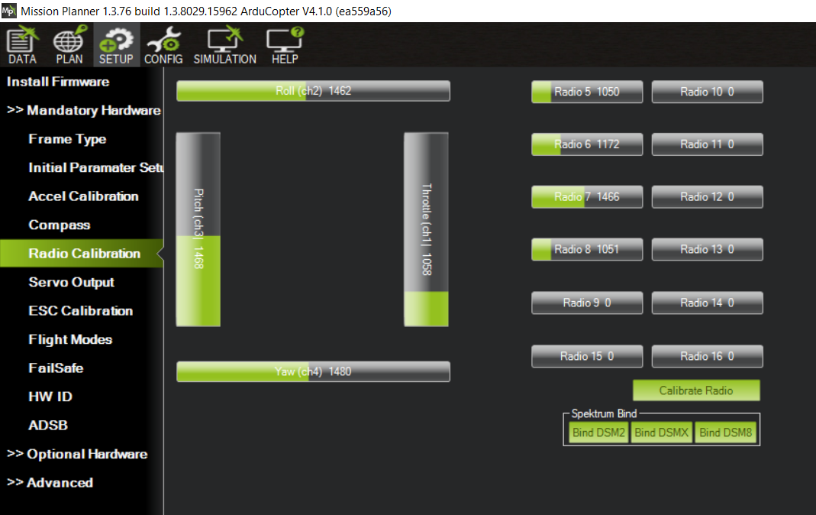

Figure 9.2‑5: RC Calibration and Values

The connection of each ESC to the Pixhawk differs from frame to frame as each configuration is tuned before operation. The Ardupilot firmware has provided a schematic for motor connection. This is for the flight control to control the correct motor as the software is unable to tell which motor is connected to which port, making it unable to control the correct motor. Hence, the motors are connected based on the diagram for a hex frame.

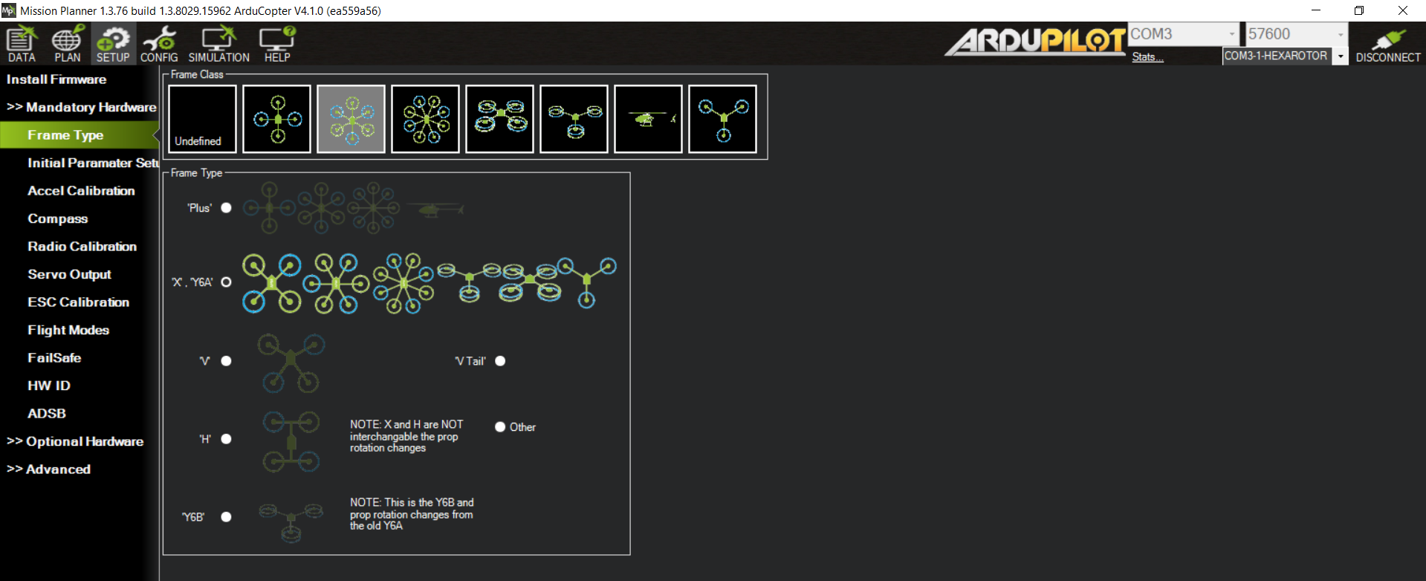

Figure 9.2‑6: Selected UAV Frame

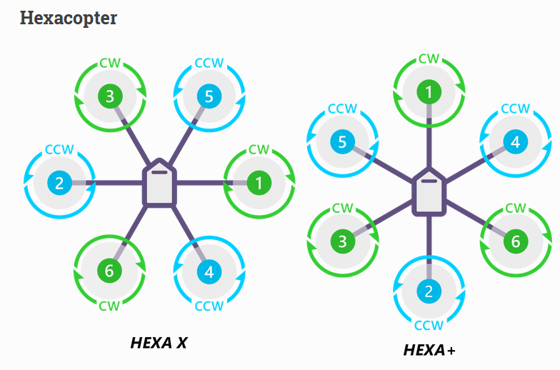

Figure 9.2‑7: UAV Motor Connection

Once the ESCs are connected based on the diagram, ESC calibration is performed, and a motor test is started for the user to confirm the correct connection of the motors. The motor test is performed without any propellers attached to the UAV to prevent injury.

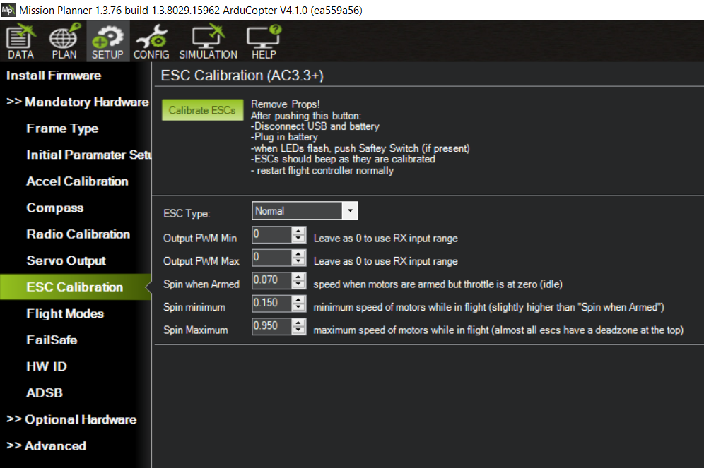

Figure 9.2‑8: ESC Calibration

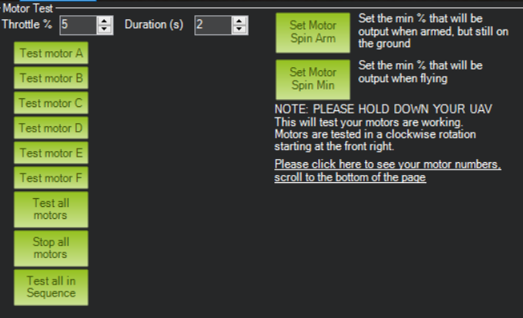

Figure 9.2‑9: Motor Test

To calibrate the accelerometer, a button on the software is used to start the process. The process guides the user to place the UAV in certain orientations and when the orientation is achieved, the user can move on to the next orientation till the process is complete.

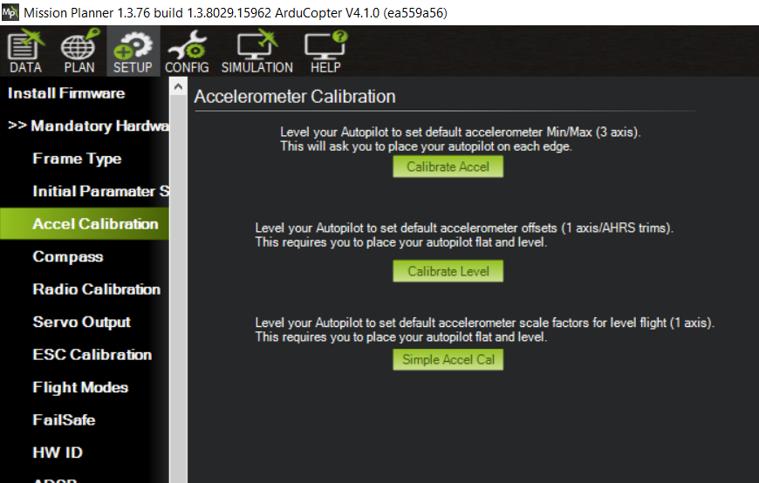

Figure 9.2‑10: Accelerometer Calibration

To calibrate the compass, a button on the software is used to start the process. The process guides the by having a progress bar of completion and the user would have to move the UAV in a figure 8 motion. Once the calibration is completed, the user is prompted to reboot the flight controller.

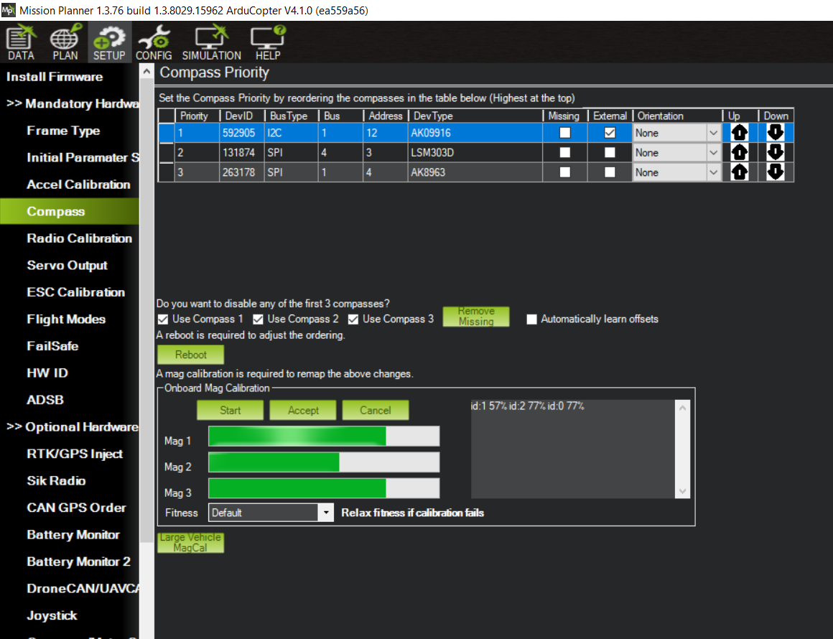

Figure 9P: Calibration Process

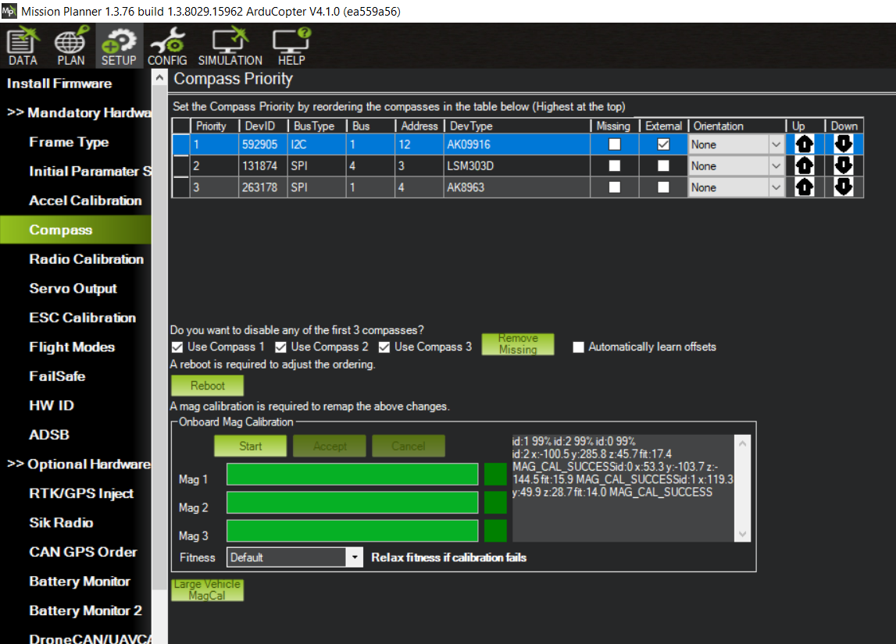

Figure 9.2‑11: Completed Calibration

Once the essential calibration is completed, the UAV is tested. A mission is planned for the UAV to fly forward to a set waypoint and return once the UAV has reached. Status is monitored on Mission Planner (GCS) over telemetry and RC control is on standby to take over.

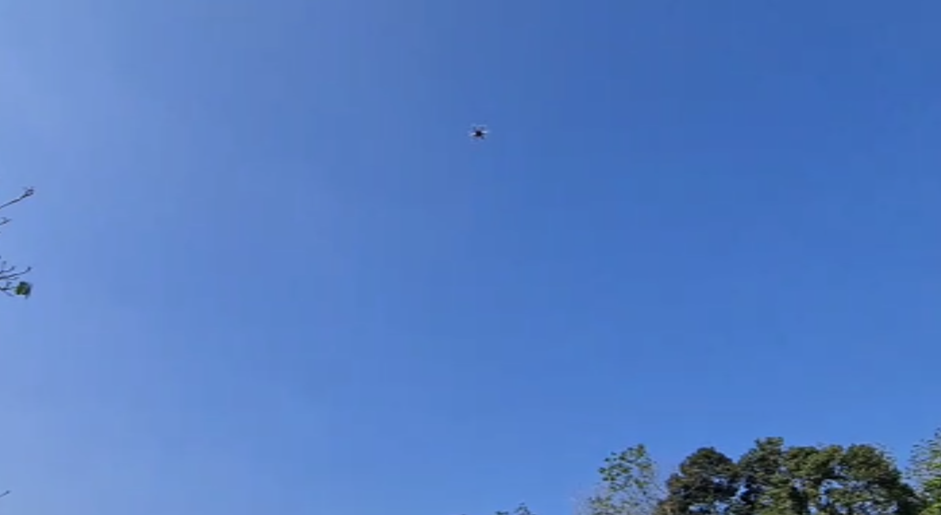

Figure 9.2‑12: UAV Performing Mission

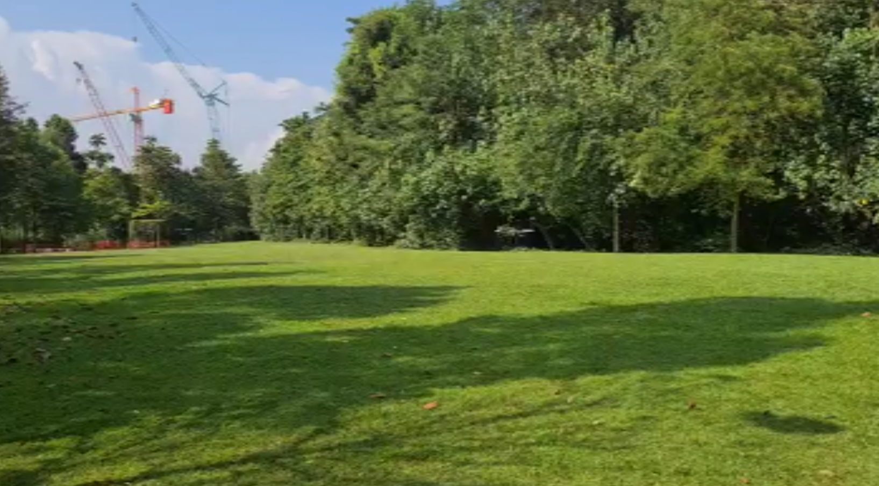

Figure 9.2‑13: UAV Landing

The initial flights of the UAV were unstable and the PID values were modified to achieve a stable flight. Thereafter, the UAV succeeded in flying autonomous at the speed of 10m/s. With the testing, the mobility of the UAV is completed, and the UAV would be able to work with input data from the companion computer. Hence, experiments for the UAV would be carried out once the computer vision module is completed.

# Experiments and Results

# Computer Vision

The selected methodology of object detection and classification in computer vision. The autonomous systems would be using the same computer vision module and share the same capabilities. For object classification and detection, OpenCV and YOLOv3 will be explored. For depth sensing, the stereoscopic vision would be used to derive depth information.

# OpenCV

The selected methodology for OpenCV would be a simple canny edge detector. By having a canny edge detector, a lightweight detection model would be used to detect objects by having their contour drawn. A picture used to simulate a wall was used. Firstly, the image was transformed into black and white and masking was applied. This allows the computer to apply a kernel to detect contours. Once contours are detected, an algorithm was used to check if a contour was within a contour. If it is, it will be labelled as a child contour. The user can then choose to filter away the child contour which reduces the information sent for computation.

|  |  |
| --- | --- |
| A picture containing indoor, vessel, barrel, camera lens  Description automatically generated  Figure 10.1.1‑1:Original Image | A picture containing icon  Description automatically generated  Figure 10.1.1‑2: Black and White Image |

|  |  |
| --- | --- |
| A picture containing polygon  Description automatically generated  Figure 10.1.1‑3: Masking (Binary Thresholding) | A screenshot of a computer  Description automatically generated with medium confidence  Figure 10.1.1‑4: Contour Detection |
| A picture containing text  Description automatically generated  Figure 10.1.1‑5: Output Contours | A picture containing text  Description automatically generated  Figure 10.1.1‑6: Removing Child Contours |

Based on the results from the canny edge detector, the algorithm can detect objects, however, the output is extremely noisy. By requiring the transforming of the image into a black and white image, the algorithm is extremely susceptible to lighting which would affect the perceived colour information, rendering the system useless. Additionally, the system is incapable of classifying the object. Hence, despite being a simple and quick algorithm, the advantages are not enough to overcome the drawbacks of the system.

# YOLOv3

To solve for object detection and classification, YOLOv3 was chosen to be tested. As training a deep learning model takes a massive amount of time and resources, the Common Object in Context (COCO) [38]dataset was chosen. The COCO dataset contains about 123,287 images and 886,284 instances. Labels include person, backpack, handbag, umbrella and many more. For this project, classification of a ball and window is required. The COCO dataset contains information on sports balls and is sufficient for the project, however, windows are not. For the project to work, a custom YOLO model is required. To do this, Label Studio is a software that allows for the labelling of images for exporting into YOLO format [39].

Firstly, Label Studio is installed using python-pip and the program is started. The software runs over localhost on a web browser. Images are uploaded and the user can draw polygons to map the location of the label.

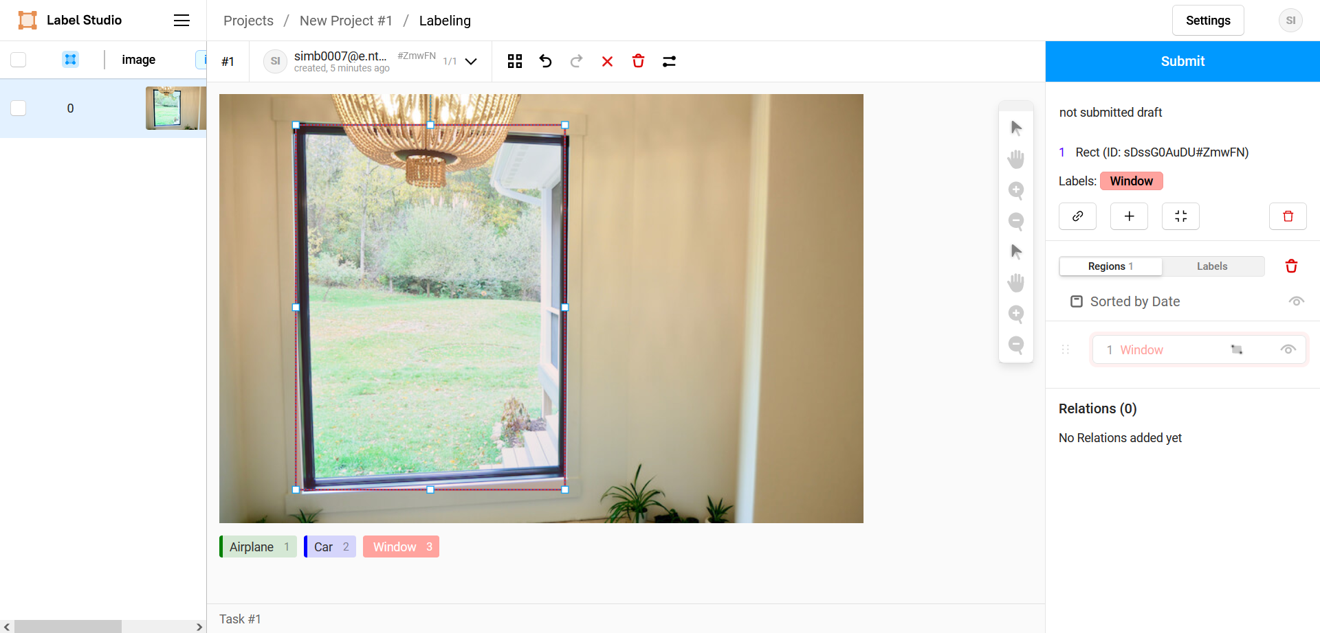

Figure 10.1.2‑1: Labelling Image for YOLO

Once the images are labelled, the data can be exported in YOLO format. Whereby the text file includes the annotations of the corresponding image file, that contains class, coordinates, height, and width.

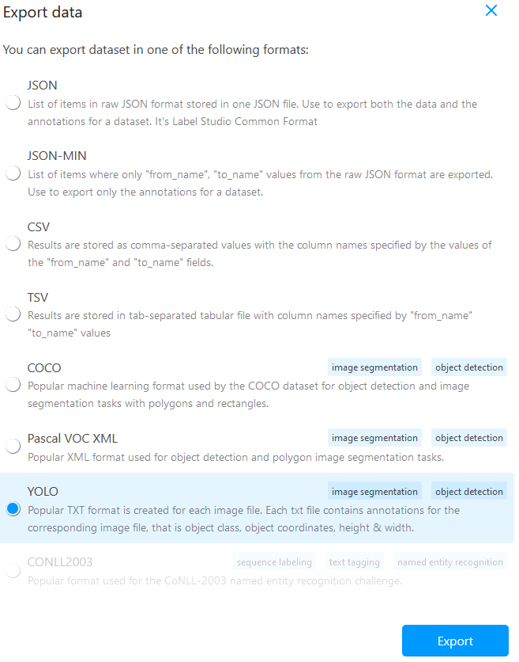

Figure 10.1.2‑2: Exporting to YOLO format

Once the images are labelled, the data can be exported in YOLO format. Whereby the text file includes the annotations of the corresponding image file, that contains class, coordinates, height, and width. This data is then used to train a pre-trained model to enhance its capabilities. This is done over Google Collaboratory, whereby the usage of an online GPU runtime saves resources on the computer.

Finally, the model is tested to detect objects. To test the model, the stereoscopic camera setup is used to detect the centre of the objects. This is so that the computer can calculate disparity and use it for depth sensing.

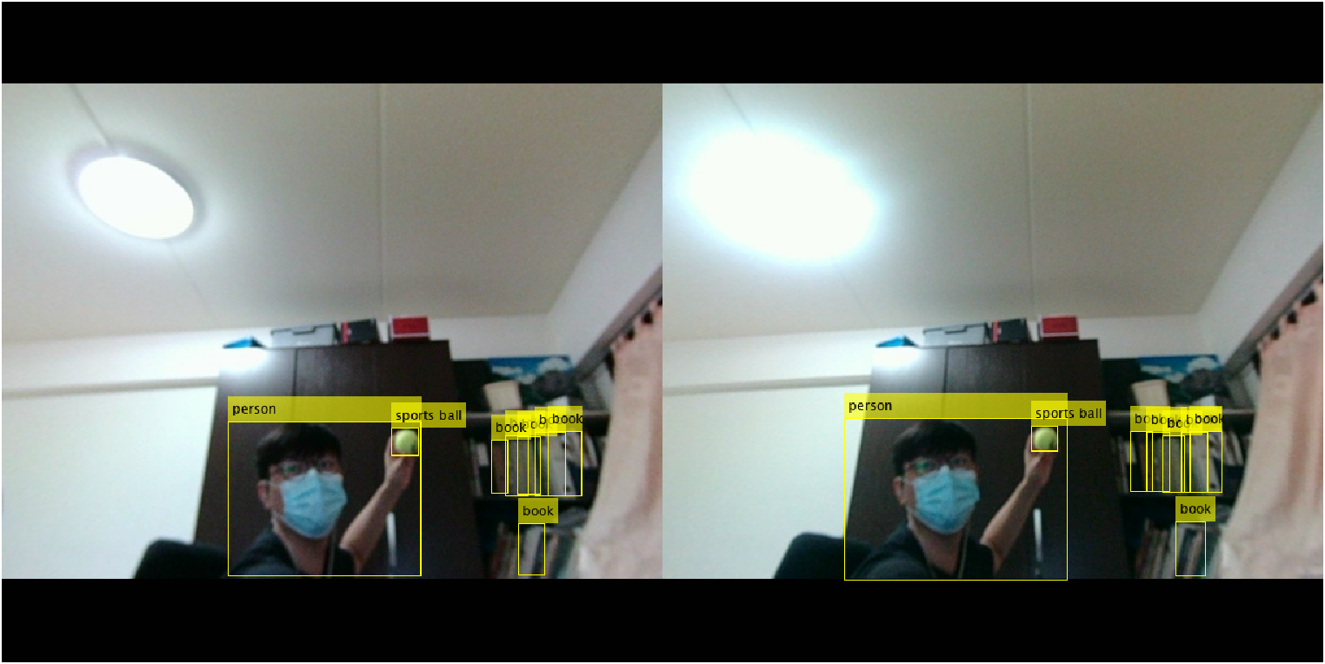

Figure 10.1.2‑3: Custom YOLO Model Results

# Depth Sensing

The proposed method for depth sensing is using a stereoscopic camera. For accurate calculation of depth, the most important step would be camera calibration whereby the extrinsic and intrinsic camera parameters are calculated and used to perform rectification. To perform camera calibration, images of a checkboard of known size are taken from different viewpoints using the camera. This allows the computer to get the real-world coordinates of the checkerboard corners. By using Matlab, the corners of the chessboard are located, and the pixel coordinates are stored.

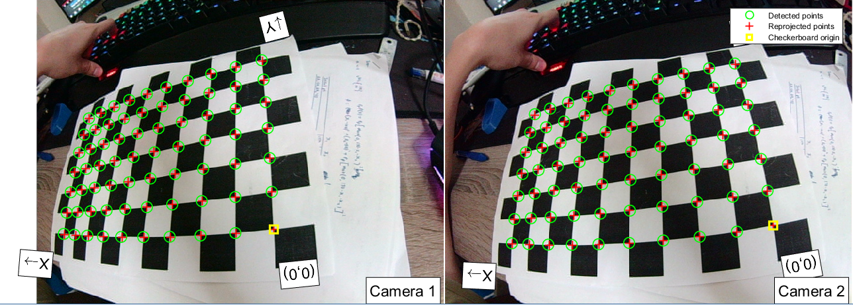

Figure 10.1.1‑1: Detection of Checkboard Corners

|  |  |
| --- | --- |
| Chart  Description automatically generated  Figure 10.1.1‑2: Camera-centric View | Diagram  Description automatically generated  Figure 10.1.1‑3: Pattern-centric View |

Once the camera parameters are calculated, it is exported for use. Using the Jetson Nano, a stereo image is taken to test the result of camera calibration. Lastly, to test the calibration a mask would be used to filter away items within 40cm to 100cm from the camera.

|  |  |
| --- | --- |
| Figure 10.1.1‑4: Left Image | Figure 10.1.1‑5: Right Image |
| Figure 10.1.1‑6: Overlayed image | Figure 10.1.1‑7: Rectified Image |
| Figure 10.1.1‑8: Applied Mask | Figure 10.1.1‑9: Masked Image |

From the images, we can see that the camera calibration was extremely successful as the lines of the walls are no longer curved. Additionally, the mask works well as objects are closer to the camera are filtered off rather decently. However, there are still spots that are supposed to be further but are not filtered by the mask. This is due to the algorithm of block matching whereby it is difficult for the computer to detect the areas with little uniqueness. Overall, the depth-sensing of the stereoscopic camera is successful.

Finally, the detection and classification model are combined with depth sensing to test if the modules can work together. Firstly, the YOLO model returns a list of categories and the coordinates of each bounding box. The list of categories is iterated through to get the indices of the wall and ball and the centre of mass of each bounding box is calculated. This is done by a simple equation.

$$Centre x_{j}=\frac{{(x}_{i}+x_{i+1})}{2}, Centre y_{j}=\frac{{(y}_{i}+y_{i+1})}{2}$$

$$Where j are the indices of catagories; i are the coordinates location$$

Equation 10.1.1‑1: Calculating Pixel Location

To obtain distance, the distance of each change in cartesian coordinates can be calculated by performing a mathematical operation based on the disparity. A series of stereo images are taken for testing.

$$Distance=b*f/d$$

$$Where b is the length between camera lens, f is the focal length, d is the disparity matrix$$

$$|Distance |=\sqrt{D_{x}^{2}+D_{y}^{2}+D_{z}^{2}}$$

Equation 10.1.1‑2: Distance calculation from Camera

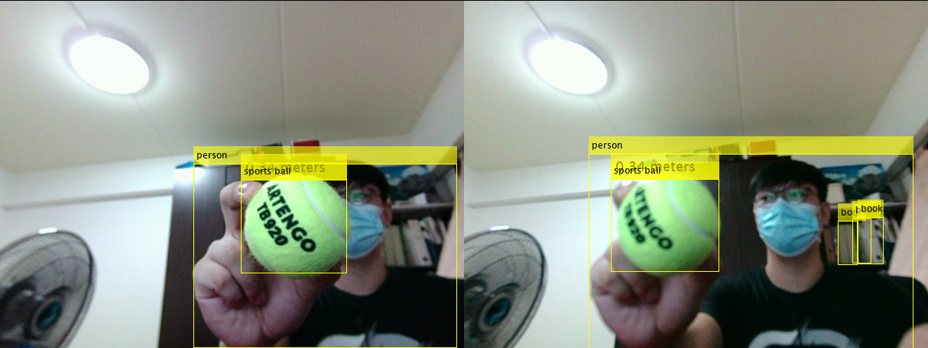

Figure 10.1.1‑10: Detection, Classification with Depth 1

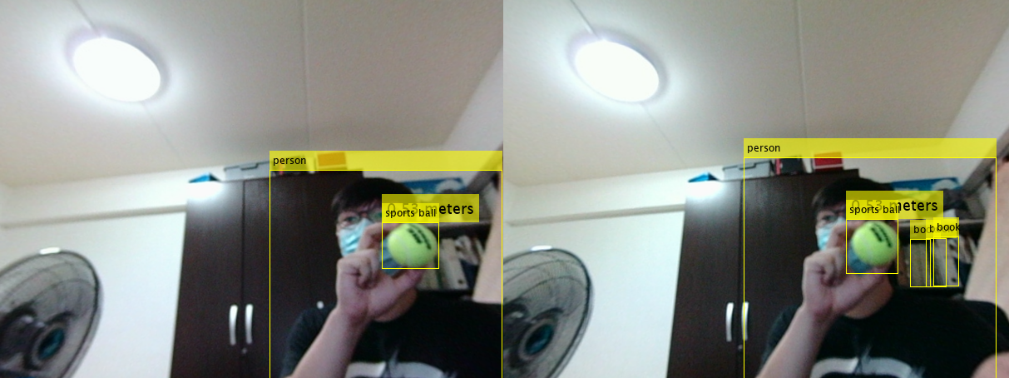

Figure 10.1.1‑11: Detection, Classification with Depth 2

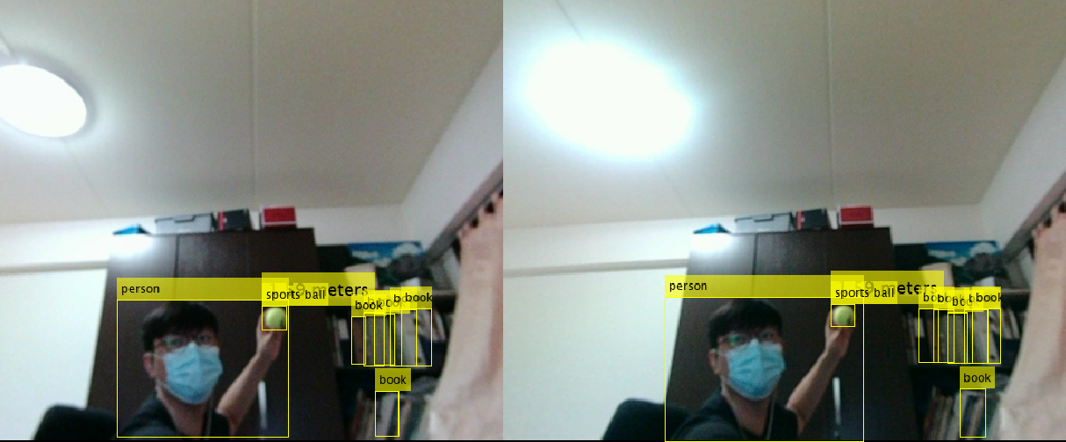

Figure 10.1.1‑12: Detection, Classification with Depth 3

Based on the results, the system can detect the depth of objects of interest. However, the performance of the model is rather slow, whereby it achieves about 15 FPS on a Jetson Nano. To overcome this, the flight controller could pause and sample actions every 100 milliseconds, providing time for computer vision to complete details for the Robotic Arm and UAV to work with.

# Robotic Arm

The previous gripper was tested to grab the tennis ball. However, it was too small to hold the tennis ball and a larger gripper was designed. The Gripper was assembled onto the arm with all other components being the same.

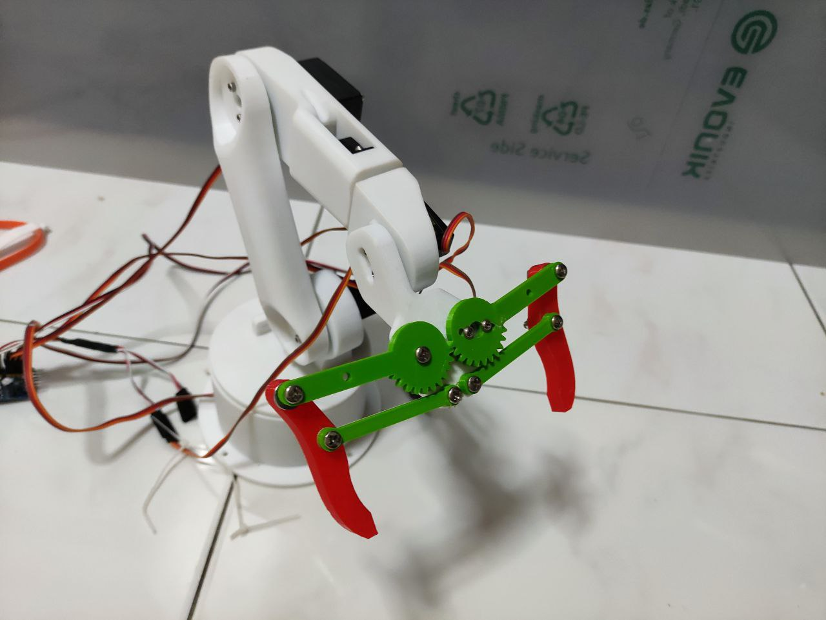

Figure 10.2‑1: Robotic Arm with New Gripper

To test the whole system of the robotic arm, the camera is attached to the robotic arm on link 4. The relative position of the camera is mapped for calculations of the relative position to the base link. The computer detects the ball and calculates the distance of the ball from the camera. Then the relative position from the end effector is calculated through FK. This allows the computer to know the relative distance between the end effector and the arm. The robotic arm then moves to the ball and if the distance is within an error of 1cm, the gripper attempts to grip. Else, the process is repeated.

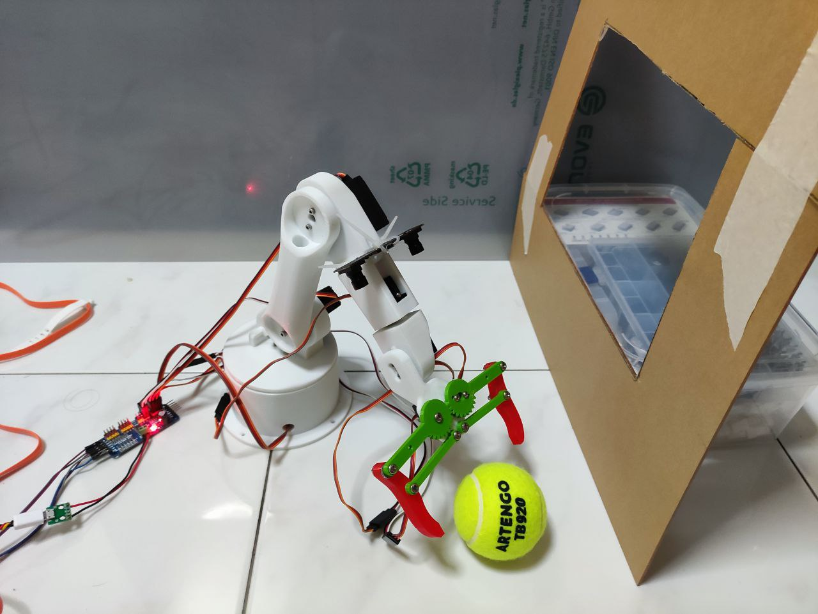

Figure 10.2‑2: Robotic Arm moving towards ball

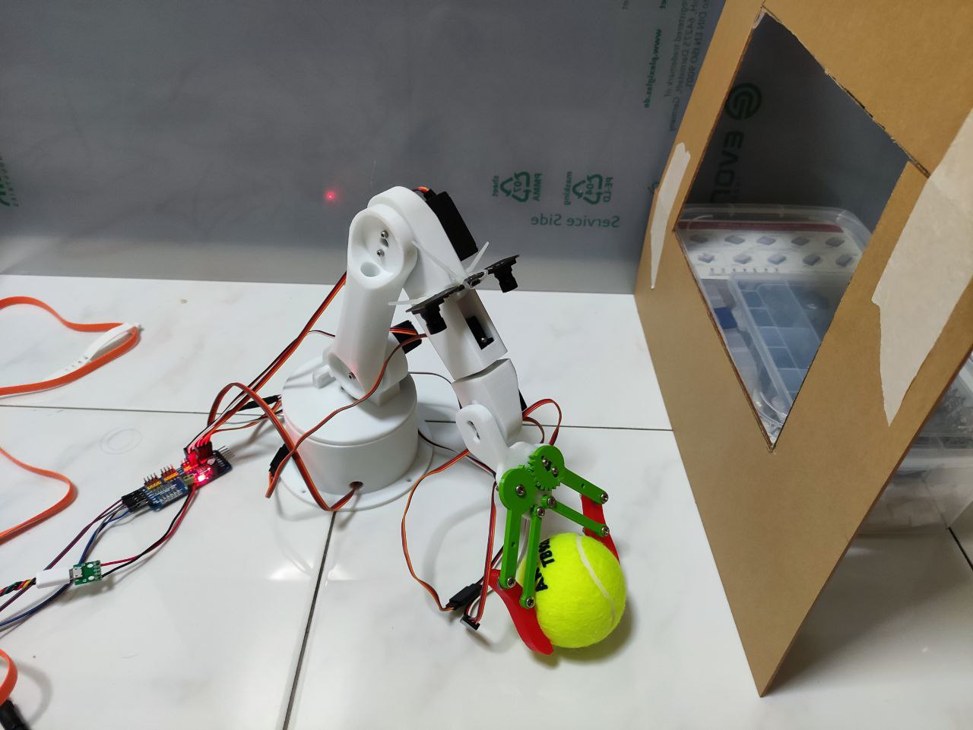

Figure 10.2‑3: Robotic Arm Grabbing Ball

Once the ball is grabbed the arm is lifted and the distance towards the window is calculated. The distance of the window is based on the average distance between the camera and the four edges of the window. This is due to the distance of the centre of the window being further as it is deeper in. Once the distance of the end effector and the wall is calculated, the final position of the arm is calculated through inverse kinematics and the robotic arm is commanded to move to that location. Once, the location is reached and the camera detects that it can no longer detect the ball, the gripper is released and after 1 second it returns to home.

|  |  |
| --- | --- |
| A picture containing text  Description automatically generated  Figure 10.2‑4: Arm Mobility 1 | A picture containing text  Description automatically generated  Figure 10.2‑5: Arm Mobility 2 |
| Figure 10.2‑6: Arm Mobility 3 | Figure 10.2‑7: Arm Mobility 4 |

|  |  |
| --- | --- |
| Figure 10.2‑8: Arm Mobility 5 | Figure 10.2‑9: Arm Mobility 6 |

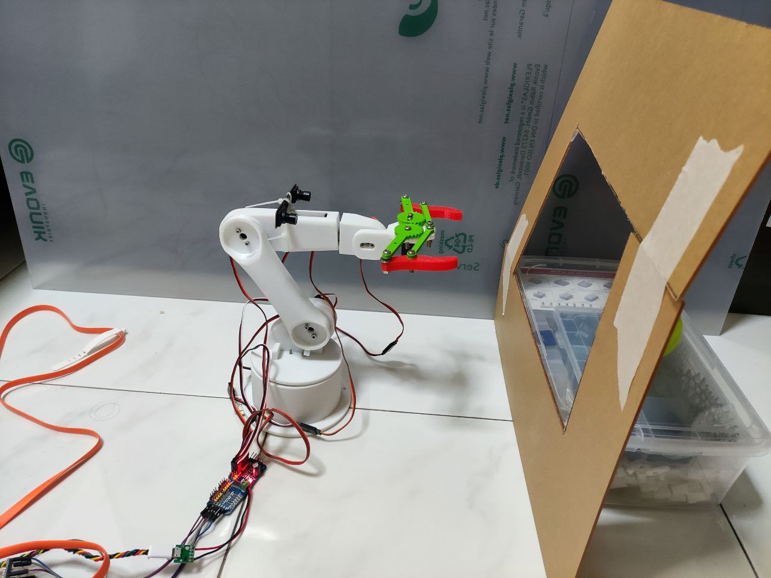

Figure 10.2‑10: Arm Returning to Zero

# UAV

Firstly, the robotic arm is attached to the UAV and the power modules for the companion computer was installed. The Jetson nano uses a high current buck converter to provide power to the Jetson Nano which requires up to 6A while operating at maximum processing speed.

|  |  |
| --- | --- |
| A picture containing indoor  Description automatically generated  Figure 10.3‑1: UAV with Gripper | Figure 10.3‑2: High Power Buck Converter |

Due to the additional components added to the UAV, the PID controller values would have to be tested and updated for stable flight. To achieve this, extended testing of the UAV is required for the stability of the UAV. To test the UAV, an RC controller was used to provide inputs to the UAV whereby the stability of the system was tested. Based on the oscillation, the response time of the UAV, the P, I, D values were manually tuned to reach an ideal state whereby the UAV has minimal oscillation and fast response time.

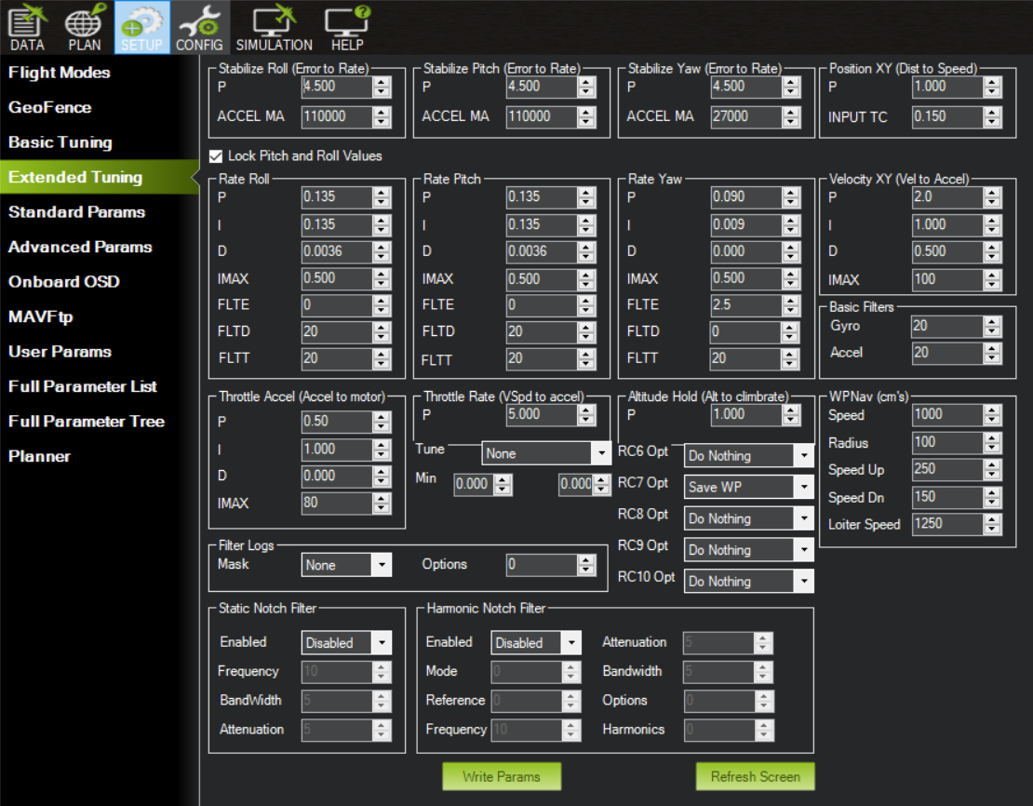

Figure 10.3‑3: PID Parameters

Once the PID values for the UAV has been tuned, the UAV’s gripper was tested whereby it detects the presence of the ball and if the distance is within the set threshold, it engages the gripper and closes it. Then, the gripper is lifted, and the UAV is ready for takeoff. The distance threshold is calculated based on FK, whereby the position from the camera to the base of the arm is known, and the link length and joint angles are used to calculate the distance the ball has to be for the robotic arm to complete grasping.

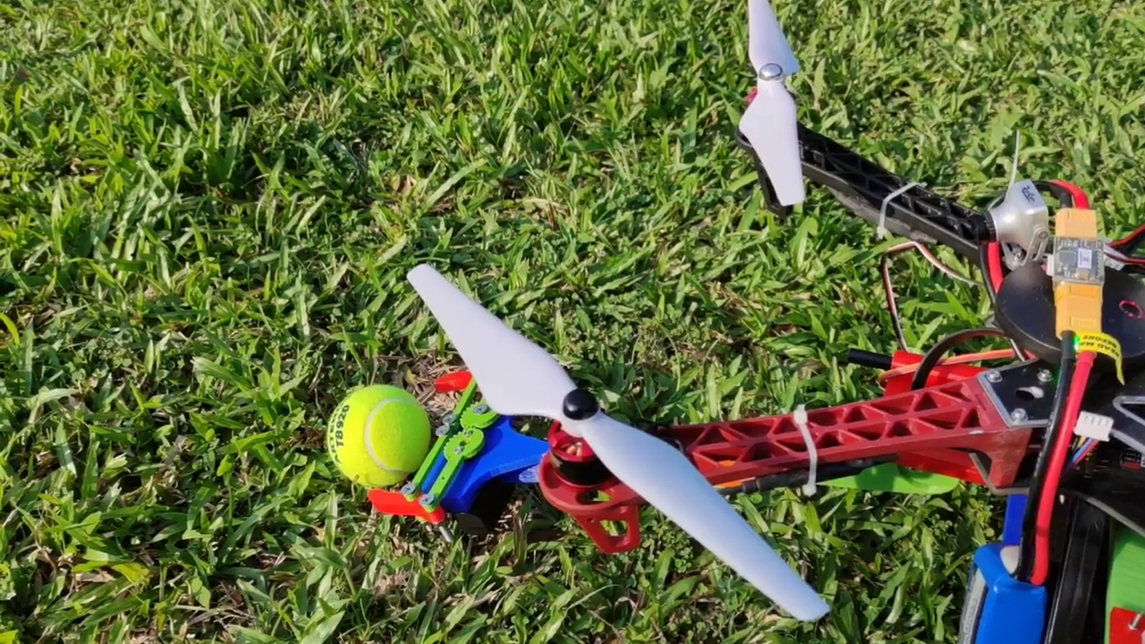

Figure 10.3‑4: UAV Detecting Ball

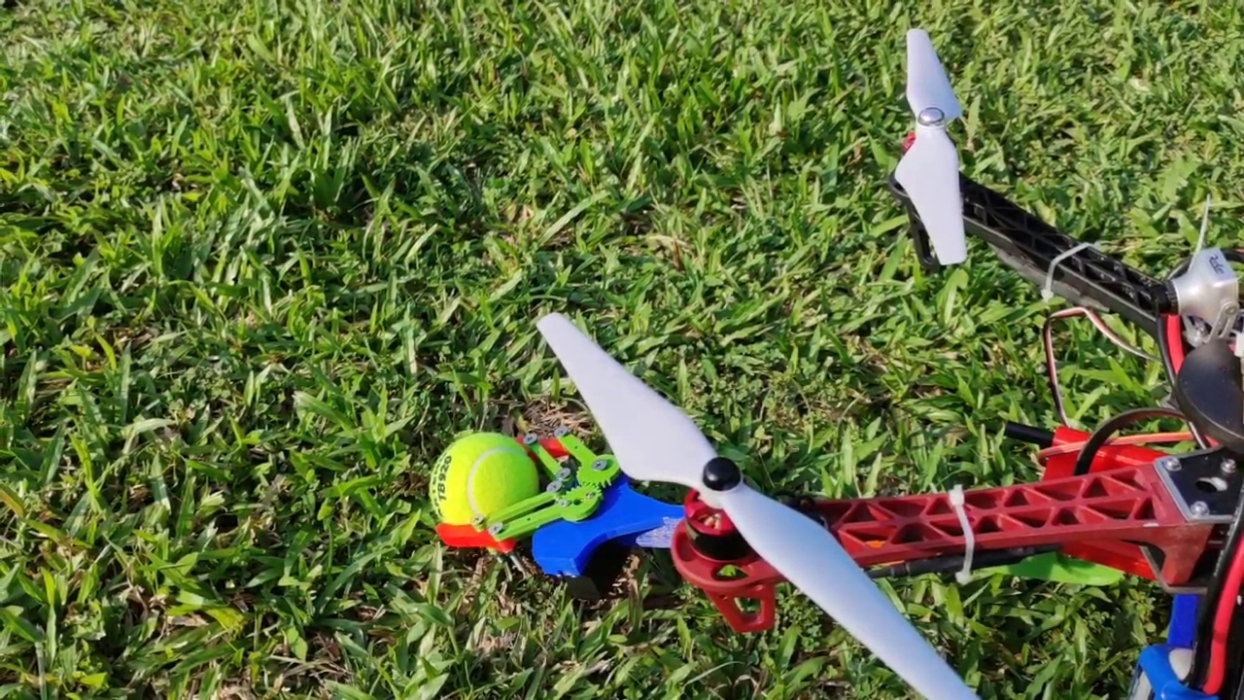

Figure 10.3‑5: UAV Grabbing Ball

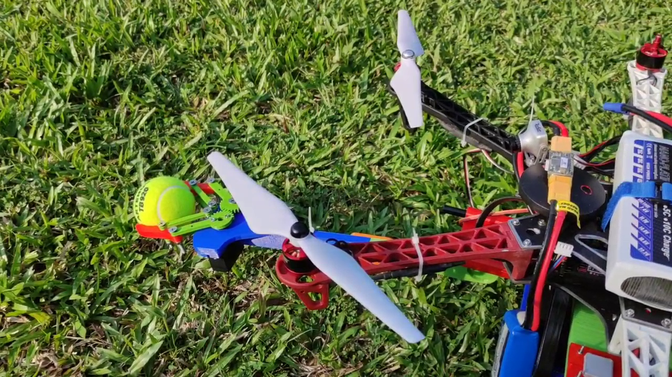

Figure 10.3‑6: UAV Raising Arm

# Conclusions and Future Works

The project was successful based on the planned schedule and functions. However, the limitations of time and funding have prevented implementations that improve the system. The bulk of the time was used to overcome hardware challenges whereby the computational capability of the system is lacking for the computational heavy tasks. Even with months of optimization, it is not sufficient to overcome the hardware limitations due to costs. Hence, future work is encouraged to improve the capabilities of the system once funding is increased.

Currently, the robotic arm is a scaled-down model which needs to be scaled up to complete the mission. By having better funding, BLDC encoded motors can deliver high torque would be used to move the joints and the robotic arm would be redesigned with metal or composite carbon fibres instead. Based on Ashby charts, expensive and lightweight metals and composites are a much better choice for robotic arms aiming to minimize weight while having high strength. Additionally, the electronics of the system could be improved by using printed circuit boards instead of protoboards that are hand soldered.

Currently, the UAV design is capable of object detection and classification as well as depth sensing. However, due to the limitations of not having an actual window for the UAV to detect and test, no further flight testing can be continued. Nonetheless, the UAV should be capable of performing the task once a window object is present. This is so as the UAV’s perception system allows the UAV to detect windows and ball objects effectively and has been tested in an indoor environment.

The current level of autonomy of the system is level 3, whereby it can sense and detect objects. However, the UAV’s planning system is rather limited due to the limited computational capabilities of the tested companion computer. To increase the level of autonomy, a possible approach would be the utilization of visual SLAM (VSLAM). By having VSLAM, the UAV would be able to map the entire surroundings of the UAV. This would allow the UAV to have the complete environment data for better path planning and an A* algorithm can be applied to allow the UAV to perform better. The hardware and software for VSLAM are already present in the system and has been tested where a point cloud is generated based on the stereo camera images. Additionally, with the Ardupilot firmware, path planning for mapping could be easily achieved. However, due to the poor computational performance, this system was removed for the UAV to function. Therefore, with higher funding, the UAV would be able to upgrade its level of autonomy by having a better companion computer.

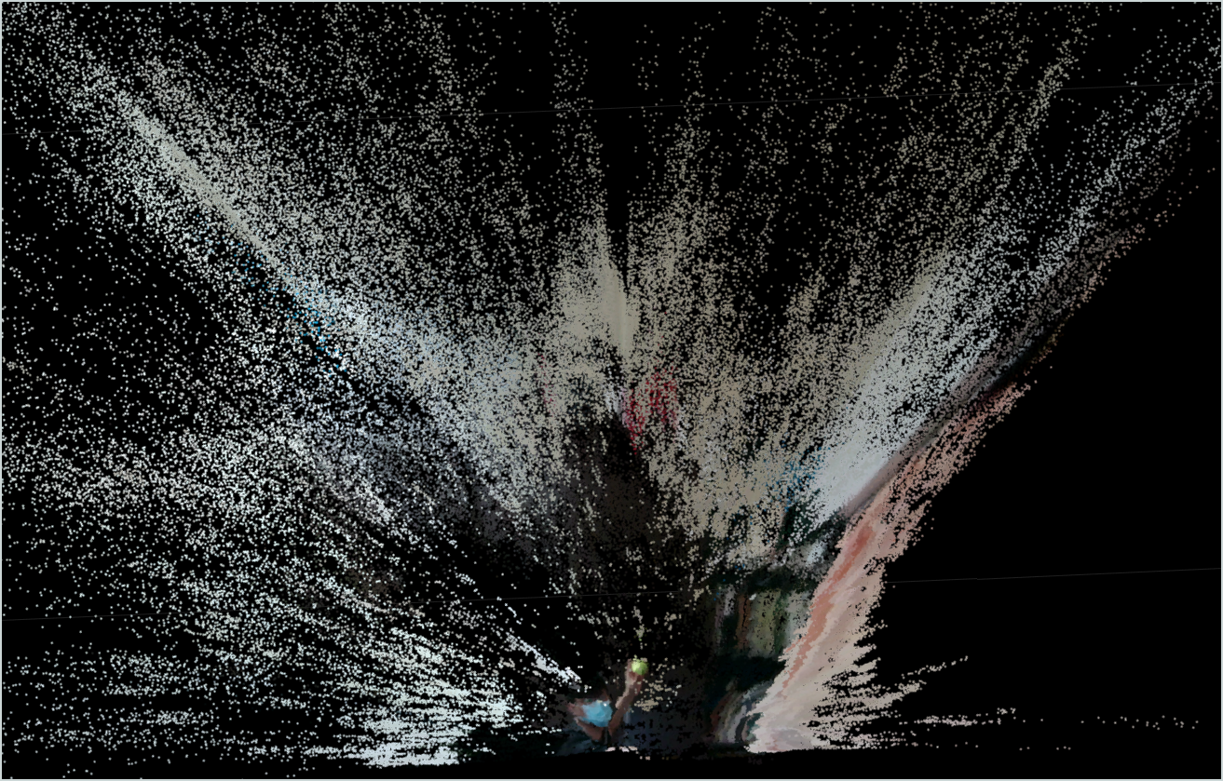

Figure 11‑1: Stereo Vision Generated Point Cloud

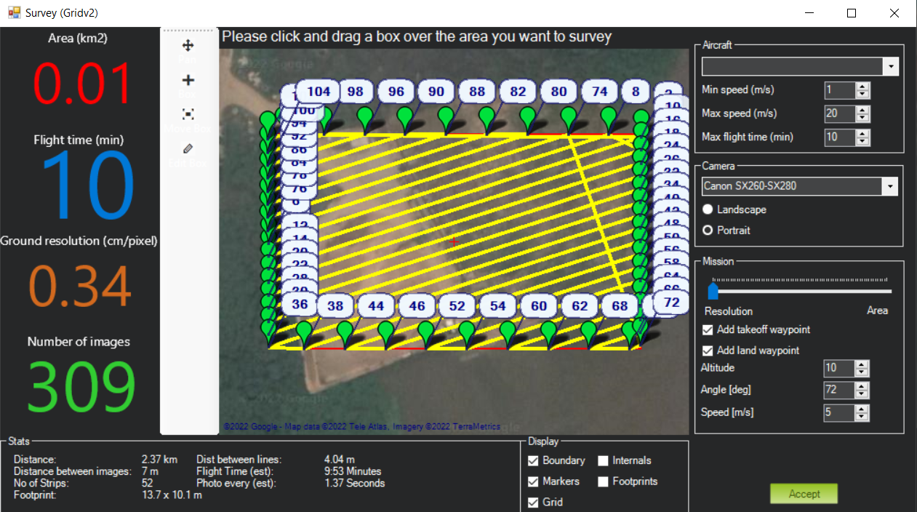

Figure 11‑2: Path Planning for Area Survey

Other hardware of the UAV can be improved as well. By using expensive carbon fibre frames and lighter robotic arms, the UAV would be able to increase the payload and range capabilities. And by having printed circuit boards, the wiring can be routed more efficiently resulting in a more compact system. Lastly, the gripper of the robotic arm could be implemented using soft robotic grippers which have been shown to improve the gripping capabilities of various objects.

In conclusion, the proposed systems can complete the given task of delivering an object to the target window. This is achieved by 3 principal components, perception, mobility, and manipulation. By having a closed-loop system, the systems can deliver the object directly to the window and will not be affected by disturbances. This method enables high efficacy and could be expanded into future usages such as warehouse object handling.

# References

[1] “Projectiles launched at an angle review (article) | Khan Academy.” https://www.khanacademy.org/science/in-in-class11th-physics/in-in-class11th-physics-motion-in-a-plane/projectiles-launched-at-an-angle/a/projectiles-launched-at-angles (accessed Feb. 27, 2022).

[2] A. Zeng, S. Song, J. Lee, A. Rodriguez, and T. Funkhouser, “TossingBot: Learning to Throw Arbitrary Objects with Residual Physics,” *IEEE Transactions on Robotics*, vol. 36, no. 4, pp. 1307–1319, Aug. 2020, doi: 10.1109/TRO.2020.2988642.

[3] “RobotWorx - Industrial Robot History.” https://www.robots.com/articles/industrial-robot-history (accessed Feb. 27, 2022).

[4] A. Zeng, S. Song, J. Lee, A. Rodriguez, and T. Funkhouser, “IEEE TRANSACTIONS ON ROBOTICS 1 TossingBot: Learning to Throw Arbitrary Objects with Residual Physics”, Accessed: Feb. 27, 2022. [Online]. Available: http://tossingbot.cs.princeton.eduhttp://tossingbot.cs.princeton.edu

[5] K. Wójcicki and K. Puciłowski, “Zbigniew Kulesza Mathematical Analysis for a New Tennis Ball Launcher”.

[6] “Open Loop and Closed Loop Animation - Inst Tools.” https://instrumentationtools.com/open-loop-and-closed-loop-animation/ (accessed Feb. 28, 2022).

[7] “What is the workspace of a typical six‑axis industrial robot arm?” https://www.mecademic.com/en/what-is-the-workspace-of-a-typical-six-axis-industrial-robot-arm (accessed Feb. 28, 2022).

[8] “boat-latest-png.png (PNG Image, 1400 × 663 pixels) — Scaled (91%).” https://bumblebee.sg/img/boat-latest-png.png (accessed Feb. 28, 2022).

[9] “NaviGator.” http://navigatoruf.org/ (accessed Feb. 28, 2022).

[10] J. Courts, J. Franklin, M. Kete, D. Hirst, J. Arens, and S. Burt, “UoN RobotX 2018 Technical Paper”.

[11] “Blog – UON RobotX.” https://uonrobotx.wordpress.com/blog/#jp-carousel-92 (accessed Feb. 28, 2022).

[12] “Work more efficiently with a power law - deparkes.” https://deparkes.co.uk/2014/07/14/how-a-power-law-can-help-you-work-more-efficiently/ (accessed Feb. 28, 2022).

[13] “servomotor - Robotic arm select servo motors - Robotics Stack Exchange.” https://robotics.stackexchange.com/questions/14504/robotic-arm-select-servo-motors (accessed Feb. 28, 2022).

[14] “The movements are based on the speed of each rotor: (a) If all rotors... | Download Scientific Diagram.” https://www.researchgate.net/figure/The-movements-are-based-on-the-speed-of-each-rotor-a-If-all-rotors-spin-at-the-same_fig1_316609149 (accessed Feb. 28, 2022).

[15] “ABB Manipulators.” https://robots.ros.org/abb-manipulators/ (accessed Feb. 28, 2022).

[16] “Fanuc.” https://robots.ros.org/fanuc/ (accessed Feb. 28, 2022).

[17] “25% of KUKA shares trade hands - The Robot Report.” https://www.therobotreport.com/25-of-kuka-shares-trade-hands/ (accessed Feb. 28, 2022).

[18] “What are the six degrees of freedom in a robot arm? – Marginally Clever Robots.” https://www.marginallyclever.com/2014/02/what-are-the-six-degrees-of-freedom-in-a-robot-arm/ (accessed Feb. 28, 2022).

[19] “kinematics - Denavit-hartenberg parameters sign 6-DOF - Robotics Stack Exchange.” https://robotics.stackexchange.com/questions/21559/denavit-hartenberg-parameters-sign-6-dof (accessed Mar. 01, 2022).

[20] “Overview of Jacobian IK. What is the math behind Jacobian IK… | by Luis Bermudez | Unity3DAnimation | Medium.” https://medium.com/unity3danimation/overview-of-jacobian-ik-a33939639ab2 (accessed Mar. 01, 2022).

[21] A. Aristidou and J. Lasenby, “FABRIK: A fast, iterative solver for the Inverse Kinematics problem,” *Graphical Models*, vol. 73, no. 5, pp. 243–260, Sep. 2011, doi: 10.1016/J.GMOD.2011.05.003.

[22] “What Is A PID Controller And How It Works? - PLCynergy.” https://plcynergy.com/pid-controller/ (accessed Mar. 01, 2022).

[23] M. Javaid, I. H. Khan, R. P. Singh, S. Rab, and R. Suman, “Exploring contributions of drones towards Industry 4.0,” *Industrial Robot*, 2021, doi: 10.1108/IR-09-2021-0203/FULL/PDF.

[24] “Canny Edge Detection Step by Step in Python — Computer Vision | by Sofiane Sahir | Towards Data Science.” https://towardsdatascience.com/canny-edge-detection-step-by-step-in-python-computer-vision-b49c3a2d8123 (accessed Mar. 06, 2022).

[25] “What Exactly Is A Gaussian Blur? | Hackaday.” https://hackaday.com/2021/07/21/what-exactly-is-a-gaussian-blur/ (accessed Mar. 05, 2022).

[26] “Graphing a Gaussian Kernel in 3-D | James D. McCaffrey.” https://jamesmccaffrey.wordpress.com/2014/01/25/graphing-the-gaussian-kernel-function-in-3-d/ (accessed Mar. 06, 2022).

[27] Z.-Q. Zhao, P. Zheng, S.-T. Xu, and X. Wu, “Object Detection with Deep Learning: A Review,” *arXiv e-prints*, pp. 1–21, 2012, Accessed: Mar. 06, 2022. [Online]. Available: https://arxiv.org/pdf/1807.05511.pdf

[28] “R-CNN, Fast R-CNN, Faster R-CNN, YOLO — Object Detection Algorithms | by Rohith Gandhi | Towards Data Science.” https://towardsdatascience.com/r-cnn-fast-r-cnn-faster-r-cnn-yolo-object-detection-algorithms-36d53571365e (accessed Mar. 06, 2022).

[29] R. Girshick, “Fast R-CNN”, Accessed: Mar. 06, 2022. [Online]. Available: https://github.com/rbgirshick/

[30] S. Ren, K. He, R. Girshick, and J. Sun, “Faster R-CNN: Towards Real-Time Object Detection with Region Proposal Networks”, Accessed: Mar. 06, 2022. [Online]. Available: https://github.com/

[31] “YOLO: Real-Time Object Detection Explained.” https://www.v7labs.com/blog/yolo-object-detection (accessed Feb. 25, 2022).

[32] “Review: SSD — Single Shot Detector (Object Detection) | by Sik-Ho Tsang | Towards Data Science.” https://towardsdatascience.com/review-ssd-single-shot-detector-object-detection-851a94607d11 (accessed Mar. 06, 2022).

[33] “What is Computer Vision? | IBM.” https://www.ibm.com/sg-en/topics/computer-vision (accessed Mar. 07, 2022).

[34] “Time-of-Flight principle (ToF): Brief overview, Technologies and Advantages.” https://www.terabee.com/time-of-flight-principle/ (accessed Mar. 07, 2022).

[35] “Exyn Drones Achieve Autonomy Level 4.” https://www.exyn.com/news/exyn-drones-achieve-autonomy-level-4 (accessed Feb. 20, 2022).

[36] “DIY Arduino Robot Arm with Smartphone Control - How To Mechatronics.” https://howtomechatronics.com/tutorials/arduino/diy-arduino-robot-arm-with-smartphone-control/ (accessed Mar. 08, 2022).

[37] “MAVLink Basics — Dev documentation.” https://ardupilot.org/dev/docs/mavlink-basics.html (accessed Mar. 09, 2022).

[38] “COCO - Common Objects in Context.” https://cocodataset.org/#explore (accessed Mar. 10, 2022).

[39] “Label Studio Blog — Quickly Create Datasets for Training YOLO Object Detection with Label Studio.” https://labelstud.io/blog/Quickly-Create-Datasets-for-Training-YOLO-Object-Detection.html (accessed Mar. 10, 2022).